Adverbs of Frequency
0% 50% 100%
______________________________________________________________________________
never sometimes often usually always
1. Adverbs usually come before the main verb.
I  She  You  They  He | never  usually  don’t often  sometimes  always | go  plays  sleep  walk  studies | to bed early.  chess at the weekend.  in the afternoon.  in the park.  in the morning.
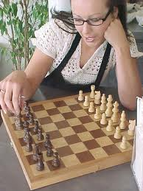

2. Sometimes and usually can also come at the beginning or at the end of the sentence.
Sometimes  Usually | we  she | drink  runs | coffee.  on the beach.
We  She | drink  runs | coffee  on the beach | sometimes.  usually.

3. Never and always can’t come at the beginning or at the end of a sentence.
Never I go to work late. We have dinner at home always.
I never go to work late. We always have dinner at home.
Online Practice Links
(Includes other adverbs also)
- http://esl.lbcc.cc.ca.us/eesllessons/adverbfreq/adfreqz.htm
- http://www.miguelmllop.com/practice/beginners/grammar/frequencyadverbs1.htm

