NAME: SECTION:
Penny Paul
Bill 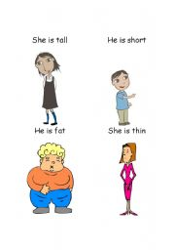 Betty
TASK ONE: Write sentences about this man. 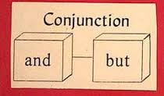
- Penny is tall and slim.
- Bill is short and _______________________.
- Paul is short and ______________________.
- Betty is _____________________________.
- Betty and Penny are___________________.
- Paul and Bill are ______________________.
- Penny ________ Paul have black hair.
- Penny has black hair _________ Betty has brown red hair.
- Bill has blonde hair but ____________________________.
- Bill is short but __________________________________.
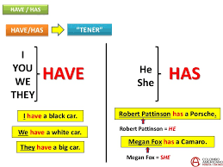
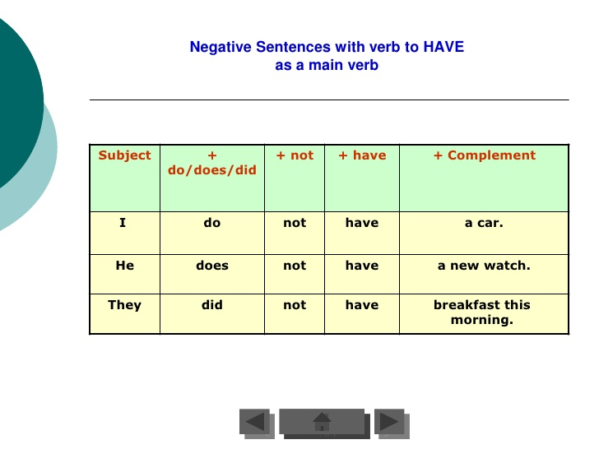
TASK TWO: Name the things in Alex’s house.

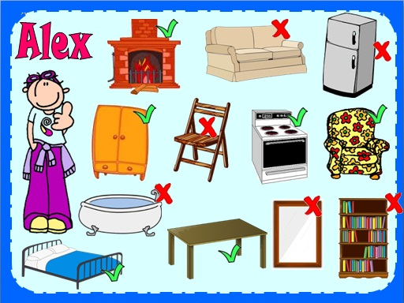

TASK THREE: Write sentences about Alex and his house.
- Alex has a ________________.
- Alex has a ________________.
- Alex does not have a __________________.
- He does not have _____________________.
- Alex does not ________________________.
- Alex has _____________________________.
- Alex has a __________________ and a ____________________.
- Alex has a __________________, but he does not have ________________.
TASK FOUR: Write what Penny has in her house.
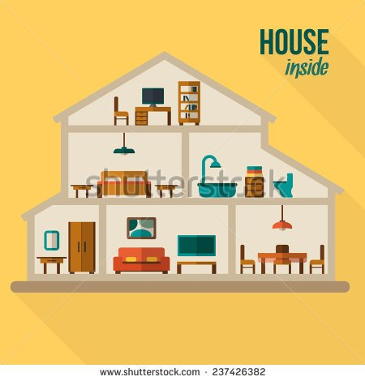
- Penny has a bookcase and Penny has lots of books.

Describing a friend BUT AND
TASK ONE: Planning what to write
Adjectives about his personality |  | Adjectives that describe his appearance
Things he has | Your friend’s name______________ | Adjectives that describe his appearance
Things he does not have | Sports he plays | Things he likes doing

TASK TWO: Describe your friend.

