Name: __________________________________________ Date: _______________
Reading about Antonia from Headway Unit 4
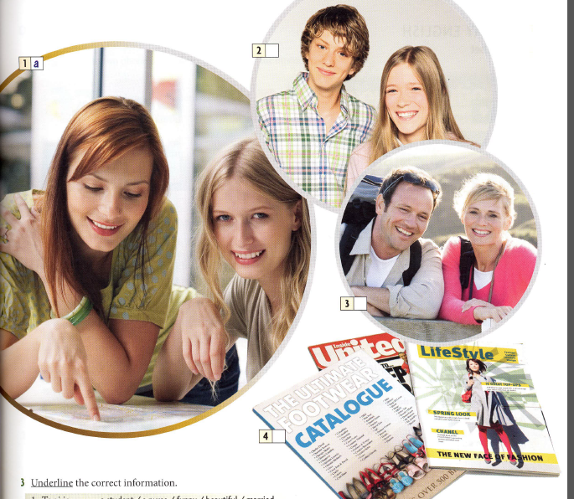

MY FRIEND ANTONIA
My best friend’s name is Antonia. She is called Toni for short. She’s very beautiful, and she’s very funny. She’s 18, and she’s a student at university in London. She has a lot of friends and a great flatmate. Her name is Valerie, she’s 19 and she’s also at university.
Toni is from the north of England. Her parents have a house in a village near Manchester, so they are British. Her father is an accountant, and her mother has a part-time job in a bank.
She has a brother and a sister. Their names are Mark and Allison. Mark is 16 and Allison is 14. They’re both at school.
Toni has a lot of clothes. Her favorite designer is Anna Sui, and her favorite shop is Top Shop. She likes shopping a lot. She also likes football. She and her brother, Mark, are big Manchester City fans. When we’re together, we have a really good time.
TASK ONE
- What kind of text is this?
A. a description B a story C a business email
2. Toni is
A a student B a doctor C a mother D ugly E married
3. Toni has
A a lot of sisters B a lot of shoes C a lot of friends D a lot of children E a lot of money
4. Valerie is
A Toni's mother B Toni's sister C Toni's teacher D Toni's flatmate E Toni's favourite shop
5. Mark is
A Toni's accountant B Toni's favourite footballer C Toni's grandfather D Toni's father E Toni's brother
6. Toni's parents have
A Top Shop B a house in a village C a house in the centre of Manchester D a favourite fashion designer E one daughter
7. Toni likes
A living in Manchester B working in a bank C going to school D playing golf E shopping for clothes
8. Choose the correct sentence
A Maryam's children are married.
B Maryam is children are married.
9. Choose the correct sentence
A what your daughter name?
B What's your daughter's name?
C What is your daughter name?
10. Choose the right sentence
A What's he's job?
B What's his job?
11. Choose the correct sentence
A They're parents have a house in Manchester.
B Their parents have a house in Manchester.
12. Choose the correct sentence
A My brother have a good job.
B My brother has a good job.

TASK TWO
We use am/is/are to talk about:
Adjectives, pl--------------, nat----------------------, age, and j------------------.

TASK THREE
Complete the table with am/is/are
I | we
he | you
she | they
it

TASK FOUR
Write a paragraph about two friends. Here are some questions that can help you write your paragraph:
What is his name?
What nationality is he?
Where is he from?
What is his job?
How old is he?
What is he like?
Start the paragraph like this:
I want to tell you about two friends. My first friend’s name is…………………………………………………

____________________________________________________________________________________________________________________________________________________________________________________________________________________________________________________________________________________________________________________________________________________________________________________________________________________________________________________________________________________________________________________________________________________________________________________________________________________________________________________________________________________________________________________________________________________________________________________________________________
My second friend’s name is …………………………………………………………………………………………………………
______________________________________________________________________________________________________________________________________________________________________________________________________________________________________________________________________________________________________________________________________________________________________________________________________________________________________________________________________________________________________________________________________________________________________________________________________________________________________________________________________________________________________________________________
TASK FIVE
Ask your partner about his friends. Fill in the chart.
 | Friend A | Friend B
Name?
Where from?
What nationality?
Job?
Describe him (adjectives)?

