Bursa’s Famous Mountain: Uludag (There is/ there are)
TASK ONE: Look at the pictures and the key words. What will the reading text be about?
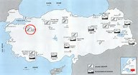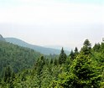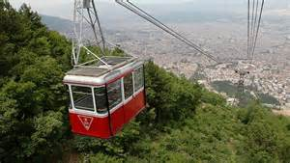
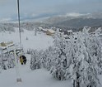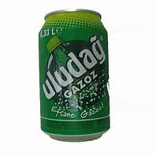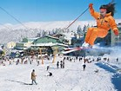
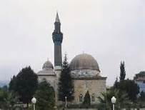
Turkey Bursa snow skiing hotels mountain water storms forest historical mosques tourists’ cool temperatures summer

TASK TWO: Match the correct heading with the paragraph

Weather Skiing Location Tourism

A.________________________________
In the north west of Turkey, near the city of Bursa, there is a high mountain called Uludag. In Turkish this means ‘Great Mountain’. It is called ‘Great Mountain’ because it is in the middle of a flat plateau and you can see it from many kilometers away.

B.__________________________________
Uludag is 2,543 m high, so it gets really cold in winter and there is enough snow to ski. Temperatures are below freezing and there are sometimes incredible snow storms because of strong winds that come from the Black Sea and Russia. People can freeze to death if they stay out on the mountain slopes without protection during these storms. However, many people choose to stay out on the mountain slopes in the summer because the weather is cool and there is a nice breeze. Down in the city of Bursa or in nearby Istanbul, temperatures can reach 40 degrees, but Uludag temperatures do not go higher than 28 degrees because the mountain is high and there is a large pine forest.

C._______________________________
In winter, it is easy to get to the ski resort because there is a road and a cable car nearly to the top of the mountain. There is a big ski resort near the mountain top with more than 16 hotels. There are several ski slopes: some are easy, but others are difficult and dangerous.
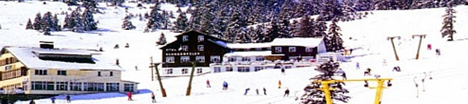

D. _____________________________
There are about one million visitors to Uludag each year. People go there to ski in the winter and picnic in the summer. The water of Uludag is very special and there is even a soft drink named after the mountain. There are also lots of thermal spas in the city of Bursa, as well as two historical mosques. The area is very popular with Arab tourists.

TASK THREE: For each sentence, say if the information is True T, False F or Not Given NG
- There is a high mountain in the north west of Turkey.
- There is snow on this mountain in the summer.
- There is a cable car up to the top of the mountain.
- There is a small hospital at the ski resort.
- There is only one ski slope on Uludag.
- There isn’t an old palace in Bursa.
- There are lots of hotels at the ski resort.
- There are deaths in winter because of dangerous weather conditions.
- There are a lot of trees in this area.
- There are not any modern mosques in Bursa.
- There are hot spas in Bursa so tourists go there.
- There are only a small number of Arab tourists in Bursa during the summer.
TASK FOUR:
When do you use ‘there is’ and when do you use ‘there are’?

When do you use ‘there isn’t a/an ’ and when do you use ‘there aren’t any ’?
Why do you add ‘s’ to a noun after ‘are’?

TASK FIVE: Write 8 sentences about Abu Dhabi or Dubai using there is/ there are, there isn’t/ there aren’t
For example, There are lots of shopping malls in Dubai and there is a very tall tower in Dubai.

