Cycle 2, Level 1, CAA, J04 Name: Student ID

TASK ONE: 30 words I remember in English

5 words I got from my friend.

TASK TWO: Dictation about Cycle 2

TASK 3: Find someone who …. 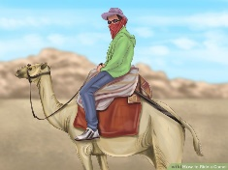 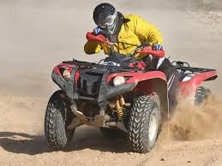
Do you ………..?
Name of student
Ride camels
Drive quad bikes
Live in Baniyas
Drive a Lexus
Have a falcon
Visit Delma Mall
Go to the cinema every week
Read M Reader books
Play football
Like biriyani
Have brothers
Drink coffee every day

TASK FOUR: Write 6 sentences about students in the class using the information from ‘Find Someone who….’
E.g. Ali rides camels.
Ali, Ahmed and Jaber ride quad bikes.

TASK FIVE: Learn words in SPELLING CITY
https://www.spellingcity.com/view-spelling-list.html?listId=11880924
Search –> teacher/parent ->
TASK SIX: Prepare to introduce yourself to your group
Write 5 things about yourself: old name city car like favourite

TASK SEVEN: Download the Penzu App.
New account - Sign up old account – sign in.

Create a new entry 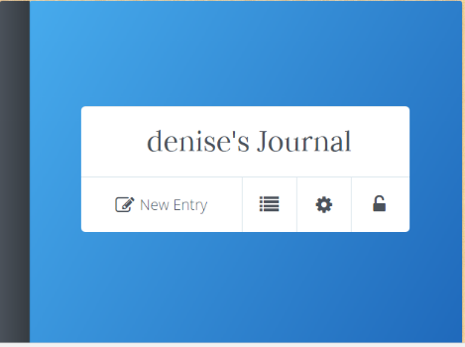
Title:
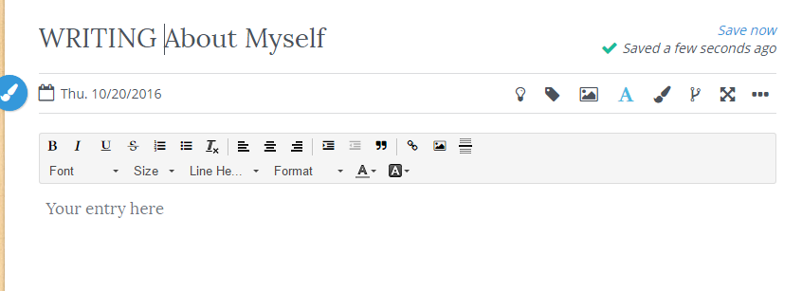
Write 100 words about yourself and add a photo of yourself.

