DECRIBING THINGS/OBJECTS/POSSESSIONS
Describing a favorite possession: Journal, camera, car, phone

MY AUNT’S JOURNAL
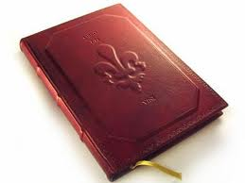 One of my favourite possessions is an old journal. My great aunt wrote in the journal between 1906 and 1932. Her name was Emma Jane Gray. She did not write in the diary every day. She only wrote in it when important things happened. For example, she wrote about the beginning and the end of World War One. She also collected the autographs of famous people such as football players and politicians. Newcastle United won the football league in 1906 and the players wrote in my aunt’s journal. 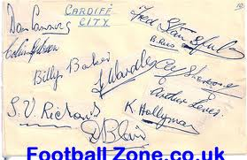

My great aunt Emma gave me the journal in 1978, a month before she died. She gave me the journal because she knew I liked it very much and would keep it safe. The journal is now 106 years old.
The journal is a small red book. The cover is leather and the pages are light brown. The pages have gold edges. There are many paintings and drawings in the book, but there are not many photos, because my great aunt did not have a camera. There are also some poems and popular sayings such as ‘ Your country needs you’. I love the book because there are a lot of pencil drawings of my family in it. There is a coloured painting of my grandfather who was Scottish. My grandfather is wearing a kilt. There is also one of my grandmother and below the picture someone wrote ‘Dora Gray. An English Rose’
I keep this journal in a bookcase in my lounge in Istanbul. I often show the journal to visitors. People are usually interested in the comments written by famous actors, sportsmen and politicians. They also like looking at the clothes people wore one hundred years ago. 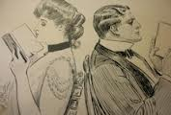 Sometimes people say I should sell the journal. One Newcastle United football fan wanted to give me $3000 for it. However, the journal is my connection with my family history. That is more important to me than money.
Written by Denise McQueen Ozdeniz
Answer the questions
- Who wrote in the journal?
- When did she write the journal?
- How old is the journal now?
- When did Denise get the journal?
- What does the journal look like?
- Where does Denise keep the journal?
- Who does Denise show the journal to?
- What do people like about the journal?
- Who wanted to buy the journal from Denise?
- Why does Denise not sell the journal?

MY CAMERA
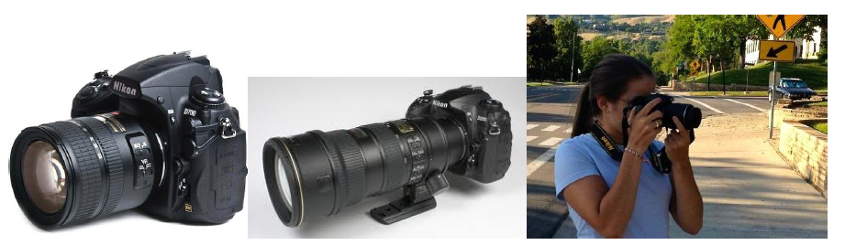

One of my favourite possessions is my Nikon camera. My best friend bought me this camera this year to take on my summer holiday. I think she bought it from a camera store in Marina Mall, but I’m not sure. I took my camera with me to China, Hong Kong, Malaysia, and Indonesia. I took so many great pictures!

My camera is black and weighs about 400 grams. It’s a DSLR, which means it is digital and you can change the lens. It has two lenses, a long one and a short one. The long lens is good for taking pictures which are far away, like sports matches and scenery. It can also record video.

The last time I used my camera was last weekend at the Rugby Sevens in Dubai. I took some great pictures of the New Zealand rugby team. When I fly to New Zealand this Thursday, I want to take it with me to take pictures of my family, and the beautiful scenery. I really love my camera, and I hope I have it for a long time.
Written by Maree Starck
Questions:
- Who bought this camera for Maree?
- What colour is the Nikon camera?
- How many lenses does it have?
- When was the last time Maree used her camera?
- Why does Maree want to take her camera with her to New Zealand?
TASK: Write about a possession you like a lot. It could be a camera, a journal or something old.

MY CAR

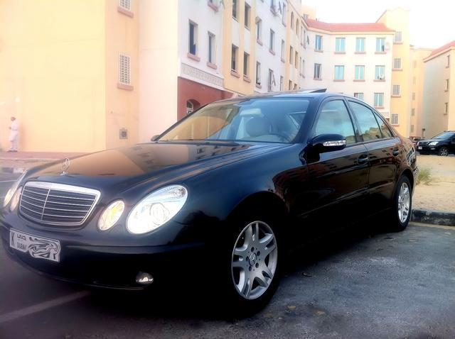
I have a Mercedes-Benz E-Class model 2006 with full options. It is automatic because I can’t drive manual. It is not new but it is an excellent car. It is Black color and in perfect condition because I wash it every day. It has four doors, parking sensors, a sun roof and a CD player. It also has comfortable leather seats. It is a very strong and fast car because it has 6 cylinders and 200-300 Horsepower. It is easy to drive because it has power steering. It has 4 airbags so it is safe in case of accident. However I always drive carefully. It has many extra features such as power windows, power locks and power mirrors.

TASK: Describe your car. Use:
- present simple ( It is/isn’t , It has/doesn’t have, It can…, I like it because…, I use it for…
- adjectives: good, excellent, modern, cool, elegant, fast complicated, easy to use, expensive, cheap…
- comparatives/superlatives: better than, the best, cheaper…
- conjunctions: and, but, because, so

MY PHONE
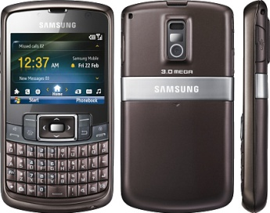My phone is Samsung Omnia. It is an excellent phone. It is a great looking phone too. It is better and prettier than Iphone. It looks a lot like the BlackBerry because it has the letters at the bottom. It is not a touch phone; it has buttons so it is very easy to use. I use one of my favorite songs as my ring tone because I do not like the ring tones which have been provided by the manufacturer. I use that song as my call and message tone. I downloaded it from a website. I have a different song for each person (contact). But I always leave my phone on silent mode because I don't like it to ring when I am in the classroom. So, when I am at home I forget and don't see some calls. Sometimes, when I see, there are 10 missed calls. My husband always complains about it, because he calls me and I don't answer the cell phone.

TASK: Describe your phone. Use:
- present simple ( It is/isn’t , It has/doesn’t have, It can…, I like it because…, I use it for…
- adjectives: good, excellent, modern, cool, elegant, complicated, easy to use, expensive, cheap…
- comparatives/superlatives: better than, the best, cheaper…
- conjunctions: and, but, because, so

DESCRIBING A THING – VOCABULARY AND KEY QUESTIONS
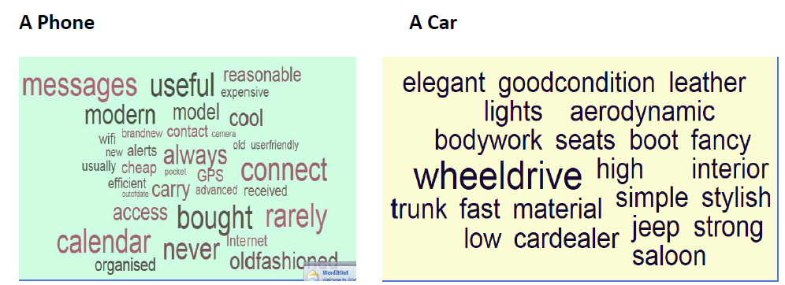
What is the thing?
What is its model?
When did you buy it? Or When did you get it?
Where did you buy it? Or Who did you get it from?
How much did it cost?
What other brands is it cheaper than?
What other brands is it more expensive than?
What colour is it?
What size is it?
Name three adjectives that describe it.
What features does it have?
What can it do? Or what can you do with it?
Where do you keep it?
How do you clean it?
Why do you like/love it?

