Denise is absent Day 1, Level One. Name: Section:
TASK 1. Make a list of the crazy, extreme sports you can do.

TASK 2. Watch these videos about people making their own boats.
https://www.youtube.com/watch?v=VPog14El4H0
https://www.youtube.com/watch?v=dt6sz1vYjQ4
TASK 3. Read the story and answer the questions
Five Crazy Russians and a Boat. 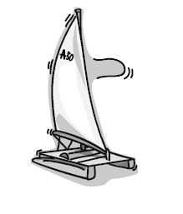

The plan: to sail from Fujairah International Marine Club across the Indian Ocean from here to Thailand, just over 4,000 miles.
The people: Five crazy Russians. These friendly guys with a strange sense of adventure are:
Evgeny Kovalevskiy (who believe it or not is a scientist not a sailor), Pavel Gridin, Anatoliy Kulik (the boat builder), Gennadiy Pikalov and Yuriy Masloboev. In fact all the adventurers are engineers or scientists.
The boat: a rubber boat measuring 8.5 metres in length and 4 metres across design and built by Anatoliy Kulik. There's a small tent to sleep in. They must be very close friends. The boat is made of rubber and has five sections each side, so even if 4 sections get damaged, one section should be enough to keep them safely afloat in the water until they repair the sections. The enthusiastic Evgeny stated, "It's possible to repair in the sea but it's very difficult. Maybe extremely difficult, but it's possible. The boat also has a small Yamaha outboard motor.
The why: The five friends are very adventurous. They look forward to the psychological situation and the inevitable difficulties they will encounter. This will be a new and exciting experience certainly for Evgeny who has never sailed before, but also for the others all of whom have a lot of experience in sailing but only on Russian lakes and Russian seas (In-land bodies of water). None of them have experience sailing on the ocean. "We decided from the very beginning to sail on the Indian Ocean," they said.
How long: The guys say it should take two months, at the worst, 25 days to the Maldives but if there are no problems then it might only be 15 days. After the Maldives the winds are from a different direction so progress could be slow. They will face their problems as they come.
The cost: Our Russian friends have worked to fund their adventure but they have had extra support. They had to buy such tools as a satellite telephone, video camera, survival tools and a video camera for documenting the trip.
Updates: The guys have an information coordinator in Siberia who will keep updating their news in Russian via the Internet.
As I watched them sail into the distance I prayed they would have a safe journey and I hoped I would see them all again at Fujairah International Marine Club in a couple of months.
Latest news: Yuriy caught a 5 kilogramme tuna fish and Evgeny has said that they should eat raw fish because of water rationing. So they do have a use for the tuna. They also have encountered a few big wave

R

Part 1 – Circle the best answer.
1. The five Russians will sail from Fujairah to
a. Russia.
b. India.
c. The International Marine Club.
d. Thailand.

2. The sailors will sleep
a. inside the boat.
b. in a tent.
c. on the beach.
d. in hotels.

3. The journey should take
a. a year.
b. six months.
c. two months.
d. twenty-five days.

4. The sailors
a. paid for almost all of the journey themselves.
b. paid for all of the journey themselves.
c. paid nothing for the journey.
d. will pay for the journey later on.

5. The boat has
a. a small Yamaha motor.
b. a small Evgeny motor.
c. no motor.
d. large sails.

6. News about the sailors can be gotten
a. on the internet.
b. by calling their information coordinator in Russia.
c. by writing to their information coordinator in Russia.
d. by watching the news on TV.

Part 2 – Read the text and tick T for True and F for False.
True False
7. Evgeny caught a 5 kilogram tuna fish.
8. They have satellite television on the boat.

9. It is possible to make repairs to the boat at sea.
10. The boat is made of wood and fiberglass.
11. Evgeny has never sailed before.

Part 3 – Food for the sailors.
Choose the best meal for each sailor.
Write A, B, C, D or E
. ______ chicken biryani.
. ______ curried fresh fish.
. ______ fish and rice.
. ______ pasta with vegetables.
. ______ beef with mushrooms and noodles.
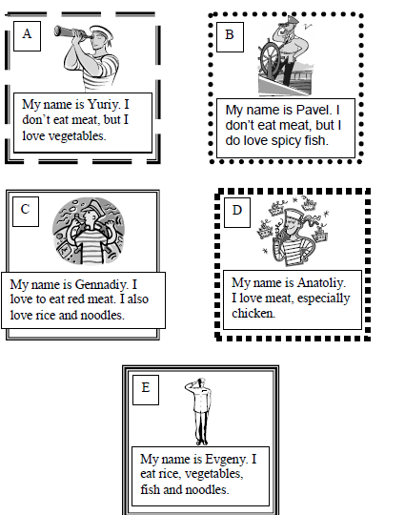
Task 4. Write about an outdoor activity you sometimes do. For example, you can write about camping in the desert, sailing, jet skiing etc.

