Describing Things: Correct these Sentences

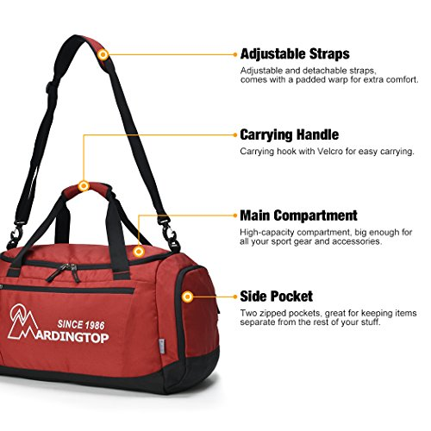

- The bag haves longs handles and big pockets.
- I have a very suitcase old.
- She has a big and black umbrella.
- My bag is big, black.
- I bought a Italian, new, leather, red jacket.
- This wool sweater feel nice and look expensive.
- The bag was too expensive and I bought it.
- The man belongs to the car.
- My father gives the laptop bags to me when I entered HCT.
- I love this phone, I will it for a long time.

