DESCRIBING CITIES Sample Writing
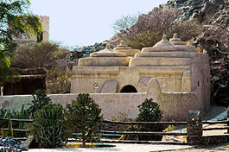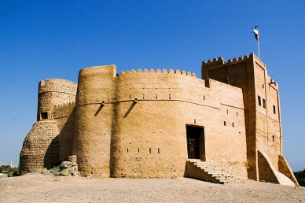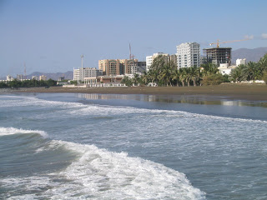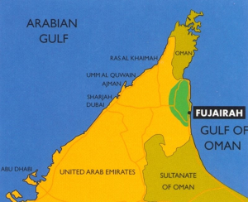
City: Fujeirah (the youngest emirate)
Location: east of the UAE
Population : 152.000
Famous places: Al Bithnah Fort, Fujeirah mountains, Al Badiyah Mosque (oldest mosque in the UAE)
Famous for: The only Emirate with no coast in Arabian Gulf , Nature
Things to do: swim in Gulf of Oman, take a boat trip to other islands

Fujeirah is one of the seven emirates of the United Arab Emirates. It is also the youngest emirate. Fujeirah is special because it is the only emirate located on the Gulf of Oman. The other emirates are located on the Arabian Gulf. As Fujeirah is on the Gulf of Oman, it is in the east of the United Arab Emirates. Abu Dhabi and Dubai are bigger than Fujeirah. Fujeirah has a population of only 152,000 because it is small. However, this emirate has a lot of history. It has the oldest mosque in the UAE called Al Badiyah Mosque. This mosque is also famous because it does not have any minarets, like the old mosques of Dalma Island. In addition to the mosque, people can visit Al Bithnah Fort.
In addition to historical places, Fujeirah is famous for its beautiful nature. This emirate has less desert than Abu Dhabi and Dubai because it has more rain. It is greener than the other emirates because it has so much rain and it gets so much rain because it has high mountains. Tourists can camp and trek in the mountains. They can also swim in the Gulf of Oman and take boat trips to other islands off the Emirati coast.
TASK ONE: Fill in the chart for because
Result | because | Reason
Fujeirah is special | because | it is the only emirate located on the Gulf of Oman.

TASK ONE: Fill in the chart for in addition or also
Information 1 | In addition,  Also, | Information 2
It has the oldest mosque in the UAE called Al Badiyah Mosque. | In addition | people can visit Al Bithnah Fort.

