WRITING: DESCRIBING OBJECTS (Things)
(Look at the picture dictionaries on http://deniseozdenizcaa.weebly.com/ to help you describe the objects.
Use: It is + adjective It has + thing It can + verb It is made of + noun
- A quad bike
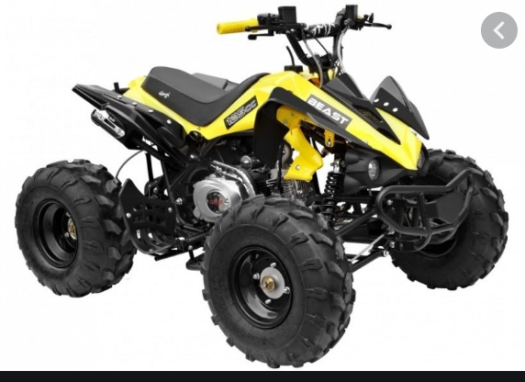

- A frisbee

- A kite
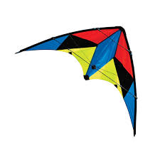

- A chessboard with chess pieces
