

**Describing Persons**

**Task 1**

**ID Card**

1. Fill in the ID card for yourself.

|  |  |
| --- | --- |
| First name |  |
| Surname |  |
| Country |  |
| Languages |  |
| Job |  |
| Age |  |
| Married |  |
| Children |  |

2. Exchange ID cards and write a paragraph about your partner.

**Task 2**

Read the paragraph about Fahad Owf. There are the following mistakes:

* 18 spelling mistakes
* 12 capital letters are missing
* 4 full stops (periods) are missing
* 1 comma is missing

**Find them and correct them.**

My name is Fahad owf i live in Abu dhabi. I an a studant at the higher Colleges. i stdyes English computing Math, and career In the morrning i work at the arrport in customs. I am marreid and I has for childs. My teecher’s nane is mr. richard. He is fron New york We works very hard in his cless. We has homwork every night I am very tird when I leave the college at nihgt.

**Task 3**

**Fill in the table below with information about yourself. Use the information in the table to write a paragraph about yourself. Write about 60 words.**

|  |  |
| --- | --- |
| **Name** |  |
| **Age** |  |
| **Married/Single** |  |
| **Children** |  |
| **Home** |  |
| **Job** |  |
| **Place of work** |  |
| **Languages** |  |
| **Hobbies** |  |

____________________________________________________________________________________________________________________________________________________________________________________________________________________________________________________________________________________________________________________________________________________________________________________________________________________________________________________________________________________________________________________________________________________________________________________________________________________________________________________________________________________________________________________________________________________________________________________________________________________________________________________________________________________________________________________________________________________________________________________________________________________________________________________________________________________________________________________________________

**Task 4**

j0212061

Complete the information in the table about yourself. Then write a paragraph of about 50 words. Remember to use the correct verb forms.

|  |  |
| --- | --- |
| Name |  |
| **Age** |  |
| **Job** |  |
| **Place of work** |  |
| **Married/Single** |  |
| **Children** |  |
| **Born** |  |
| Home |  |
| **Hobbies** |  |
| Languages |  |
| Study |  |

______________________________________________________________________________________________________________________________________________________________________________________________________________________________________________________________________________________________________________________________________________________________________________________________________________________________________________________________________________________________________________________________________________________________________________________________________________________________________________________________________________________________________________________________________________________________________________________________________________________________________________________________________________________________________________________________________________________________________________________________________________________________________________________

______________________________________________________________________________________________________________________________________________________________________________________________________________________________________________________________________________________________________________________________________________________________________________________________________________________________________________________________________________

____________________________________________________________________________________________________________________________________________________________________________________________________________________________________________________________________________________________________________________________________________________________________________________________________________________________________________________________________________________

**Task 5**

**Write about a famous person.**

Starting sentence : A very famous person in the Arab world is………………………………….

[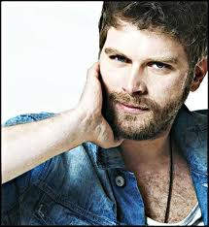](http://www.google.com/imgres?q=kivanc+tatlitug+2011&hl=en&biw=1058&bih=521&gbv=2&tbm=isch&tbnid=cnni74vNJwc9XM:&imgrefurl=http://beren.ahlamontada.com/t1109-topic&docid=3d4UBYmPKqBr9M&w=492&h=536&ei=RWBsToCQCZKQ4gTdorDVBA&zoom=1)

Name: Kıvanç Tatlıtuğ

Age: 28

Nationality: Turkish

From: Adana, in the south of Turkey

Place of residence: Istanbul

Job: Actor and model

Marital Status: Married

Brothers and sisters: four

Hobbies: Swimming, playing basketball, drawing

Languages: Turkish and English

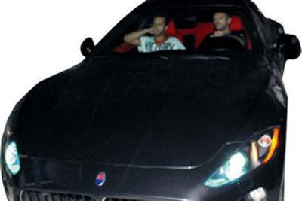

Finishing sentence: In conclusion, Kivanc is………………………………………………………………..

____________________________________________________________________________________________________________________________________________________________

____________________________________________________________________________________________________________________________________________________________

______________________________________________________________________________

____________________________________________________________________________________________________________________________________________________________

____________________________________________________________________________________________________________________________________________________________

____________________________________________________________________________________________________________________________________________________________

______________________________________________________________________________

____________________________________________________________________________________________________________________________________________________________

**Task 6**

Use the following information to write a paragraph about Ali Abdullah

Age : 24

Job : Teacher

Place of work : Abu Dhabi Men’s College

Married/Single : Married Children: 3 (2 boys, 1girl)

Home : Khalidiya/Abu Dhabi

Hobbies : Tennis, reading, watching videos

Languages : Arabic, English, French, Farsi

____________________________________________________________________________________________________________________________________________________________

____________________________________________________________________________________________________________________________________________________________

______________________________________________________________________________

____________________________________________________________________________________________________________________________________________________________

______________________________________________________________________________

**Task 7**

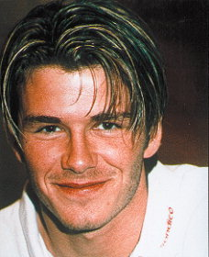David Beckham is a famous football player. He was born in London, England on 02/05/1975. He is 180 cm tall and weighs 67 kg. He is a right midfielder for the LA Galaxy football team in Los Angeles. He is married and has three children.

|  |  |
| --- | --- |
| **PROFILE** | |
| First name: |  |
| Surname: |  |
| Job: |  |
| Position: |  |
| Club: |  |
| Birth place: |  |
| Birthdate: |  |
| Age: |  |
| Height: |  |
| Weight: |  |
| Married/Single |  |
| Children |  |

____________________________________________________________________________________________________________________________________________________________

____________________________________________________________________________________________________________________________________________________________

______________________________________________________________________________

____________________________________________________________________________________________________________________________________________________________

______________________________________________________________________________

____________________________________________________________________________________________________________________________________________________________

____________________________________________________________________________________________________________________________________________________________

______________________________________________________________________________

____________________________________________________________________________________________________________________________________________________________

______________________________________________________________________________

**Task 8**

Use the information below to write a paragraph about John. You may use these verbs: **is has lives works likes speaks**

|  |  |
| --- | --- |
| Name | John Doe |
| Age | 43 |
| Job | Maintenance Engineer |
| Place of Work | Abu Dhabi Road Construction |
| Marital Status | Married |
| Children | 2: 1 boy, 14 years, 1 girl, 12 |
| Home | Tourist Club |
| Hobbies | Sailing, swimming, photography |
| Languages | English, some Urdu |