

**Describing Places**

**Task 1**

Vocabulary for Describing Places

**Port -coast -mountain –factory- industrial -city -modern -buildings -farming -village -date palm tree -market -dhow -mosque -fort**





**Task 2**

**Parts of a description of places ( country, city)**

1. **Introduction:**

* Why are you writing about it .
* What is it?
* Where is it?

*I Live in Dubai. It is the biggest and the most exciting city in UAE but it is not the capital. It is situated on the coast of Arabic Gulf, between Sharga and Abu Dhabi.*

1. **Information about population**

* Who lives there?
* How many people?
* What kind of people?

*There are 2 million people in Dubai. People from many different countries live here so we have lots of good food and music. Most people are expats and they speak English. There are only 15% Emirates so only a few people speak Arabic.*

1. **Description of the place (places of interest)**

* What is/isn’t there?
* What does it have?
* *There are many interesting buildings in Dubai. Burj Khalifa is the tallest building in the world and Burj Al Arab is one of the most expencsive hotels. Dubai has many excellent shopping malls where you can buy anything you want. There are many excellent reastaurants which sell Lebanese, Indian and Italian food. Dubai also has lots of beautiful beaches and interesting theme parks.*

1. **Information about the weather**

* What is the weather like in summer?
* What is the weather like in winter?
* *In summer , Dubai is very hot and humid but in winter the weather is very pleasant.*

1. **Conclusion**

* Why do you like it?
* Why do you live there?

*I like living in Dubai because the climate is great and it’s a very relaxed city.*

* ***NOTE:* Remember to use adjectives, negatives and sentences with and, but, because.**

**Parts of a description of places ( country, city)**

1. **Introduction:** Why are you writing about it ?What is it? Where is it?

_____________________________________________________________________________

______________________________________________________________________________

_____________________________________________________________________________

______________________________________________________________________________

1. **Population:** Who lives there? How many people? What kind of people?

_____________________________________________________________________________

______________________________________________________________________________

_____________________________________________________________________________

______________________________________________________________________________

1. **Description (places of interest):** What is there? What does it have?

_____________________________________________________________________________

______________________________________________________________________________

_____________________________________________________________________________

______________________________________________________________________________

_____________________________________________________________________________

______________________________________________________________________________

1. **The weather:** What is the weather like in summer/winter?

_____________________________________________________________________________

______________________________________________________________________________

1. **Conclusion:** Why do you like it? Why do you live there?

_____________________________________________________________________________

______________________________________________________________________________

*Describing your home*

**Parts of a description of places**

1. **Introduction:**

* **Why are you writing about it .**
* **What is it?**
* **Where is it?**

*I live in a small flat but it is very comfortable. It is in a huge, new building in a nice quiet street near Cornish . The flat is on the fifteenth floor so it has a wonderful view.*

1. **Information about people who live with you**

* **Who lives there?**
* **How many people?**
* **What kind of people?**

*I live there with my family, my husband , my daughter and my dog.*

1. **Description of the place**

* **What is/isn’t there?**
* **What does it have/doesn’t have?**

*There are only two bedroom s and two bathrooms in my apartment but there is a large living room with separate dining and a lovely, big , sunny kitchen. It doesn’t have a study nor a maid’s room. There isn’t a garden of course but there is a nice , spacious balcony. There is a beautiful swimming pool on the ground floor as well. It also has a garage downstairs and the gym on the second floor.*

1. **Conclusion**

* **Why do you like it?**
* **Why do you live there?**

*I like this flat very much because it’s near schools, shops and the Cornish.*

* ***NOTE:* Remember to use adjectives, negatives and sentences with and, but, because.**

*Describing your home*

* **Introduction:** Why are you writing about it ? What is it? Where is it?

_____________________________________________________________________________

______________________________________________________________________________

_____________________________________________________________________________

* **People:** Who lives there? How many people? What kind of people?

_____________________________________________________________________________

______________________________________________________________________________

_____________________________________________________________________________

* **Description of the place :** What is/isn’t there? What does it have/doesn’t have?

_____________________________________________________________________________

______________________________________________________________________________

_____________________________________________________________________________

_____________________________________________________________________________

______________________________________________________________________________

_____________________________________________________________________________

* **Conclusion:** Why do you like it? Why do you live there?

_____________________________________________________________________________

______________________________________________________________________________

_____________________________________________________________________________

* **Remember to use adjectives, and sentences with and, but, because**

**Task 3**

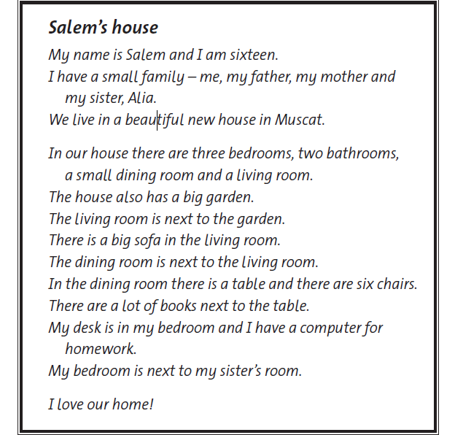

1. Read about Salem’s house aloud.
2. Underline all the rooms in Salem’s house.
3. Circle the things in the rooms in Salem’s house.

**Task 4**

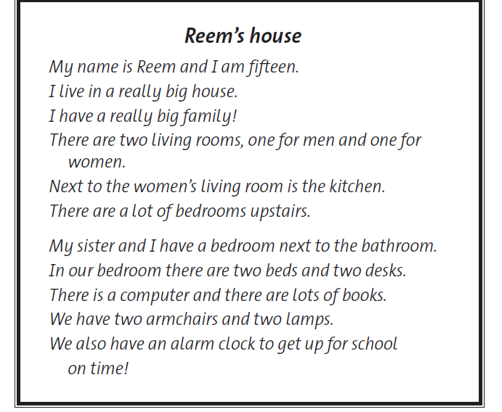

1. Read about Reem’s house.
2. Underline the things in Reem’s house.
3. Write a short paragraph about your house.

____________________________________________________________________________________________________________________________________________________________

____________________________________________________________________________________________________________________________________________________________

____________________________________________________________________________________________________________________________________________________________

____________________________________________________________________________________________________________________________________________________________

____________________________________________________________________________________________________________________________________________________________

____________________________________________________________________________________________________________________________________________________________

____________________________________________________________________________________________________________________________________________________________

____________________________________________________________________________________________________________________________________________________________

**Task 5**

**Writing About a City or Town**

1. **Today I will write about the** (lovely, beautiful), (industrial, touristic) **city/ town of** (name of town or city)
2. (name of town or city) **is located in the** (north, south, east, west ) **of** (country)
3. **It is situated** ( in the hills, in the desert, on the coast, on the river (name of river), on the border with Oman)
4. **It has a population of** …………………………
5. (name of town or city) **is famous for** …………………………………………..
6. **Some of the city is very modern. It has tall tower blocks and modern**…………………………………………
7. **Parts of the city are historical. People started living in (**name of town or city) ----------------- **years ago. There is a** (beautiful, peaceful, traditional) **old mosque and** …………………………..
8. **When you visit, you can see** ……………………………………….
9. **You can also eat** ………………………….
10. **Visitors can go to the** ……………………………..
11. **I like this place because it has**……………………………………………………….
12. **I like this place because it is** ………………………………………………………….

______________________________________________________________________________________________________________________________________________________

______________________________________________________________________________________________________________________________________________________

______________________________________________________________________________________________________________________________________________________

______________________________________________________________________________________________________________________________________________________

______________________________________________________________________________________________________________________________________________________

______________________________________________________________________________________________________________________________________________________

______________________________________________________________________________________________________________________________________________________

______________________________________________________________________________________________________________________________________________________

______________________________________________________________________________________________________________________________________________________

**Task 6**

Directions – fill-in the blanks with one word each.

I live in _____ house ______the sea. It’s ______ old house, about 100 years old, _______it’s __________ small. There _____ two bedrooms upstairs, ________ no bathroom. The bathroom ______ downstairs next _______ the kitchen and there’s a living room ______ there’s a lovely ________ fireplace. There’s a garden in front ______ the house. The garden ______ down to the beach, and in spring _______ summer there _______flowers everywhere.

I _________ alone, ________ I have a lot ______ visitors. My friends ______ stay with

_____________. I love my house __________ it is close to the sea.

**Task 7**

Read the text.

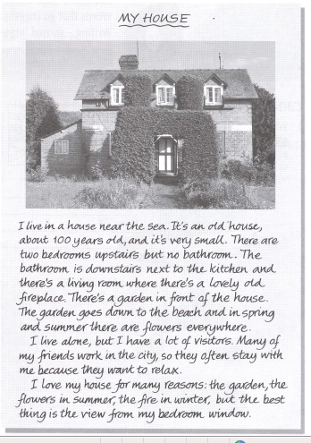

1. Write a similar description of your house or flat in about 100 words.

* Where is it?
* Is it old or new?
* How many rooms are there?
* Is there a garden?
* Who do you live with?
* Do you like it? Why? What is the best thing?

______________________________________________________________________________________________________________________________________________________

______________________________________________________________________________________________________________________________________________________

______________________________________________________________________________________________________________________________________________________

______________________________________________________________________________________________________________________________________________________

____________________________________________________________________________________________________________________________________________________________________________________________________________________________________________________________________________________________________________

______________________________________________________________________________________________________________________________________________________

______________________________________________________________________________________________________________________________________________________

______________________________________________________________________________________________________________________________________________________

____________________________________________________________________________________________________________________________________________________________________________________________________________________________________________________________________________________________________________

**Task 8**

**Directions – Complete and use the information in the table to write a paragraph about Dubai. Use any other information that you know.**

|  |  |
| --- | --- |
| **Town/City** | **Dubai** |
| **Country** |  |
| **Situated** |  |
| **Population** |  |
| **Famous for** |  |
| **Interesting Places** |  |
| **Activities** |  |

____________________________________________________________________________________________________________________________________________________________________________________________________________________________________________________________________________________________________________

____________________________________________________________________________________________________________________________________________________________________________________________________________________________________________________________________________________________________________

____________________________________________________________________________________________________________________________________________________________________________________________________________________________________________________________________________________________________________

**Task 9**

**Complete the table with information about Abu Dhabi. Then write a paragraph using the information.**

|  |  |
| --- | --- |
| **name** |  |
| **city/town/village** |  |
| **country** |  |
| **situated** |  |
| **population** |  |
| **famous for** |  |
| **interesting places** |  |
| **activities** |  |

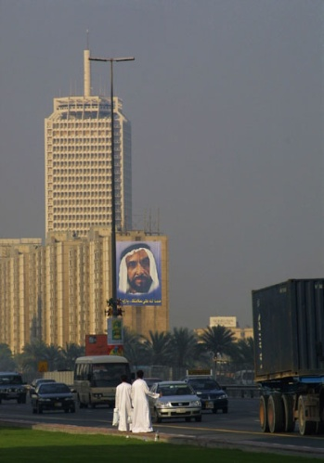

_________________________________________________________________________________________________________________________________________________________________________________________________________________________________

______________________________________________________________________________________________________________________________________________________

______________________________________________________________________________________________________________________________________________________

______________________________________________________________________________________________________________________________________________________

**Task 10**

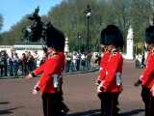

**Fill in the missing parts of the table. Use the information to write a paragraph**

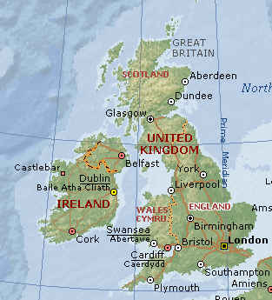

|  |  |
| --- | --- |
| **name** | London |
| **city/town/village** |  |
| **country** |  |
| **situated** |  |
| **population** | 4 million |
| **famous for** | London Bridge  Big Ben |
| **interesting places** | old castles  interesting museums |
| **activities** | walking in the parks  shopping in High Street |

______________________________________________________________________________________________________________________________________________________

______________________________________________________________________________________________________________________________________________________

______________________________________________________________________________________________________________________________________________________