FINAL GRAMMAR EXAM PRACTICE
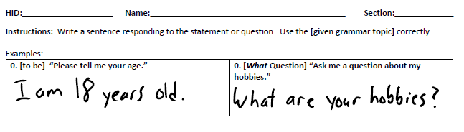
- (Simple past) Tell me about the National Day Celebrations at College. | 10. (Time- preposition) When did you start this course?
2. (Simple past question) Ask me about my summer holiday in July 2015. | 11. (Place – preposition) Where are the computers in HCT?
3. (Simple past negative) Did you bring your family to the HCT open day? | 12. (Place – preposition) Where is the teacher’s computer?
4. (Could) Tell me about a skill you did well as a child, but you cannot do now. | 13. (Time- preposition) When is your winter break?
5. (Can) Ask me about dancing the stick dance. | 14. (Gerund) Tell me one thing you like doing. (Replace the verb ‘like’ in your sentence with another verb)
6. (Must negative) Tell me a rule about smoking in shopping malls. | 15. (Infinitive) What are your hopes for your future? (Use the verb hope)
7. (Should) Give me advice about staying healthy. | 16. (A little/ a few) How much sugar is in Arabic coffee?
8. (Have to) Ask me a question about bringing a sick note to HCT after being absent. | 17. (How much/many) Ask me a question about the things in my pocket.
9. (Must negative) Tell me about the no phone calls in class rule. | 18. (There is/are negative) How many houses are on The Moon?

