Find someone who can…. 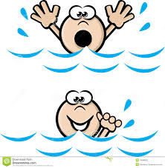
Skill | Name of student
Ride a camel
Ride a horse
Drive a quad bike
Build a fire
Hunt with a falcon
Sail a yacht
Play a musical instrument
Windsurf
Play football
Swim
Cook
Take good photographs

