Grammar Structures for Part 2 of the Speaking Exam
TASK: Family Part 2
Examiner: In some families, young people do work at home to help their parents. Which jobs do you think teenagers can do? Decide together the best types of work that young people could do at home.
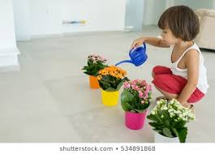
Comparative (2 things)
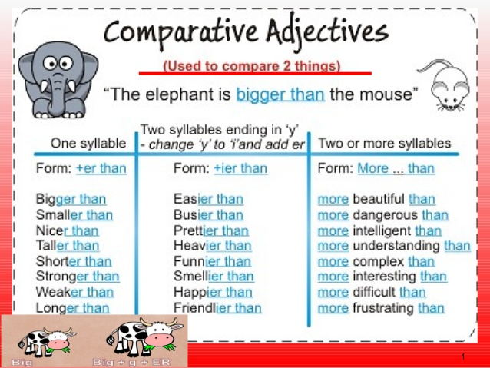
Watering flowers is easier than painting a wall.
Painting is more difficult than watering flowers.
Taking care of plants is more suitable for children.

Superlative (3 or more things)
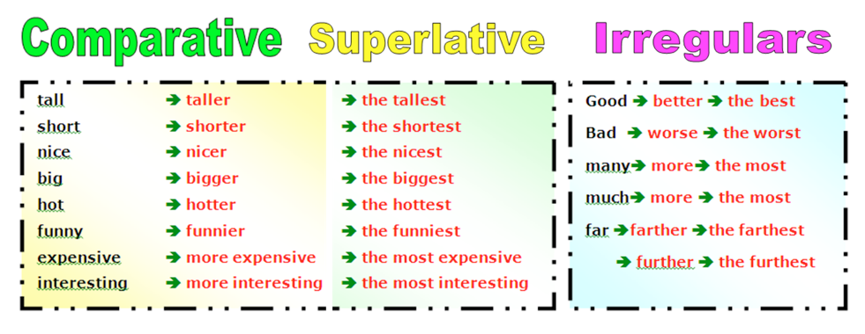
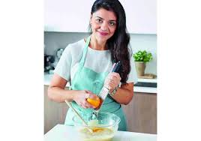
Taking care of plants is the best activity for children because it is safe.
Painting is the most dangerous activity for children.
Painting is the worst activity.

Too (problem)
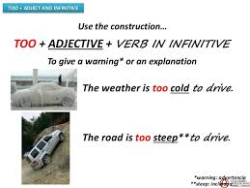
Painting a wall is too difficult for children.
Painting is too messy for children.
Cooking is okay, but using a knife is too dangerous.

Should/ Should not
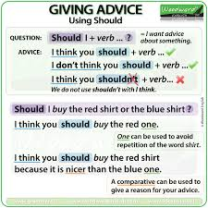
Children should not use knives and hot ovens because they get hurt.
Children should not use paint because they might drink it or get it in their eyes.

If for making decisions
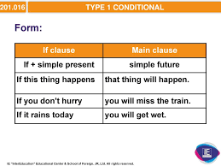
If children want to help their families, they can water plants.

TASK: Practice Activities – now you try
Routine Part 2
Examiner: Mariam and her husband are both doctors at Khalifa Hospital. Their work routine is difficult and stressful, so they need some relaxation activities after work and at weekends. Decide together on the best ways for them to relax.
Here are some pictures to help you.
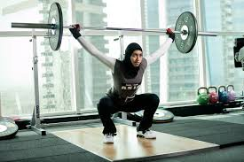 Use comparative, too and if

Use superlatives, should and if
Final Step of Speaking Part 2: Making a decision

