How often do you 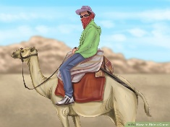 ? How often do you 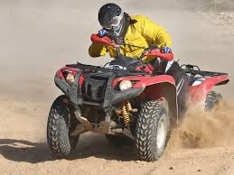?
NAME:
SECTION:
Activity | Sentence about the student | Student’s signature
Ride a camel | Hamed never rides a camel.
Drive a quad bike
Visit Dubai
Eat chicken biriyani
Visit Delma Mall
Go to the cinema
Read stories on Study Ladder
Play football
Speak Turkish
Forget your phone at home
Drink soft drinks

Study the words for this worksheet on https://quizlet.com/242493716/activities-flash-cards/?new

