How to use MS Forms
- Go to forms.office.com
- Log in with your H00… and password
- Click on New Form

- Type in the title of your research study and add a description
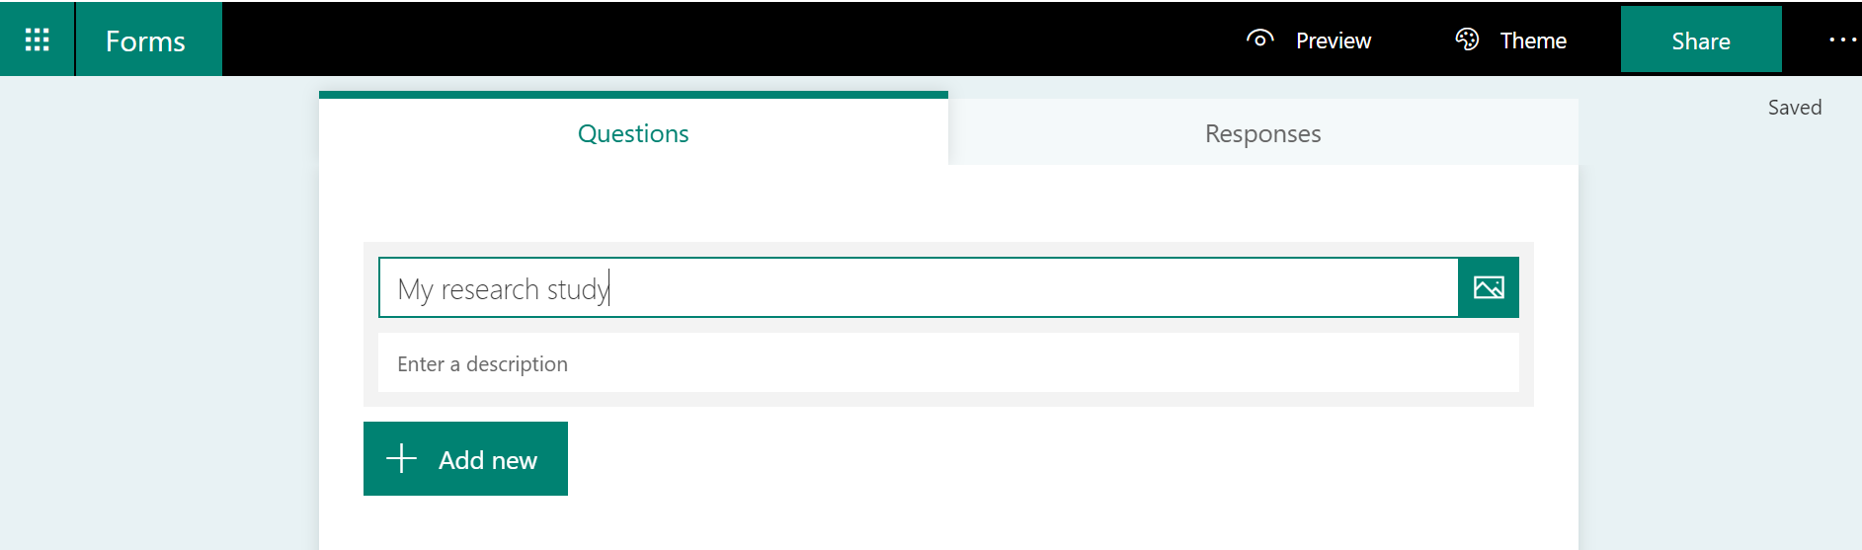

- Click on Add New to add your first question
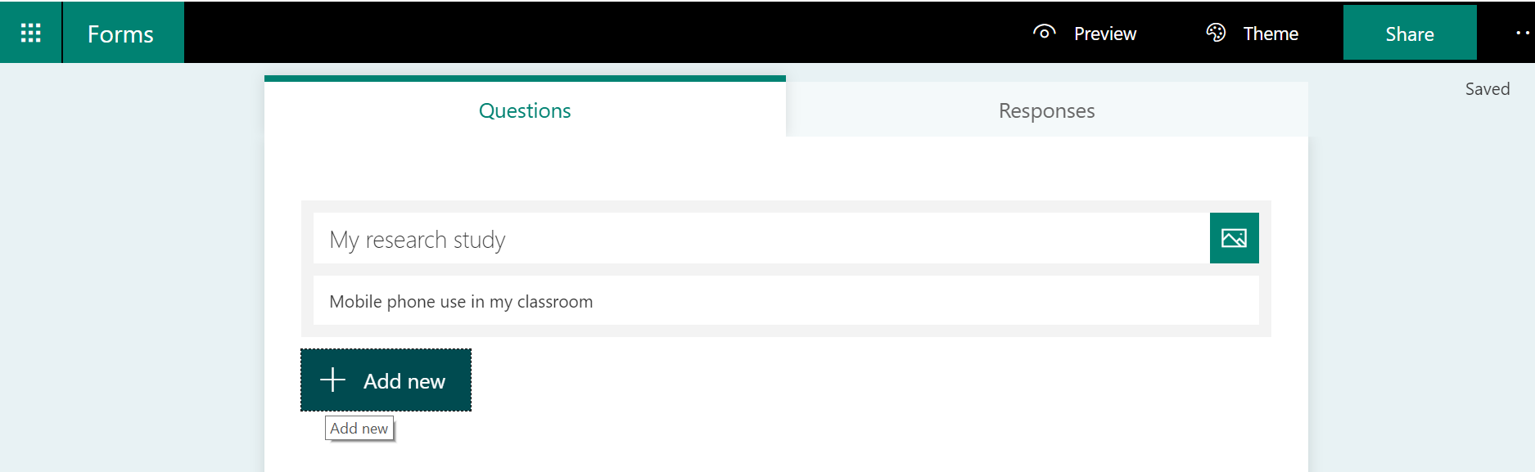

- Decide which question(s) you would like to ask
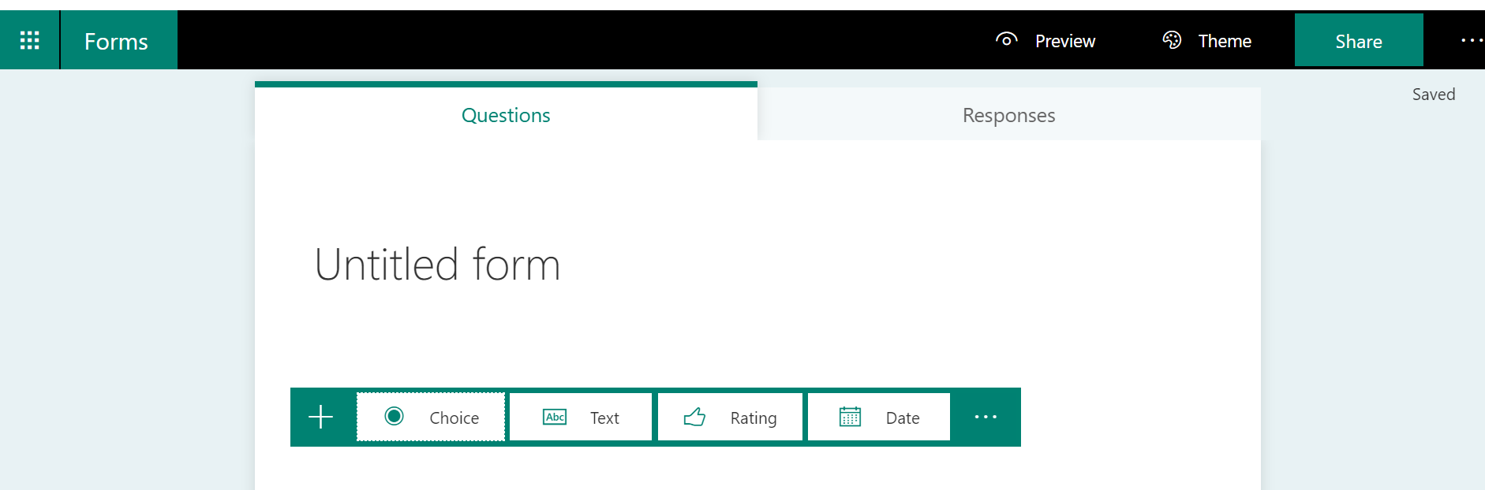

- When you have added your questions, share the link to your survey with your classmates
