Reading: Ibn Battuta’s Travels
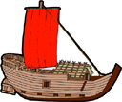

1 In the box below are modes of transportation. In your group, write them under the different categories in the table. Some means of transportation can fit under more than one category.
helicopter train bicycle

motorboat dog sled automobile

horse skis balloon

rocket magic carpet jet

camel sailboat time machine

bus on foot wormhole

subway taxi donkey

wagon submarine jetski

quad

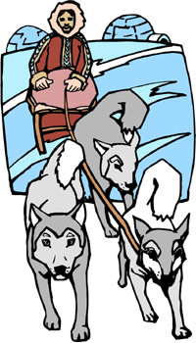
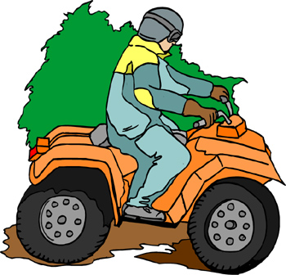

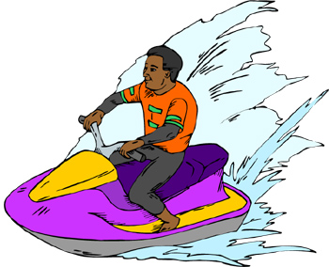
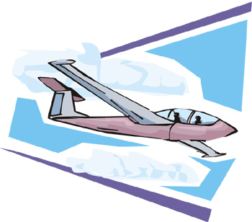

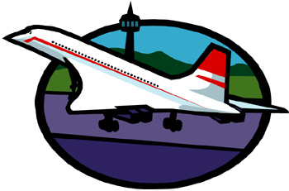
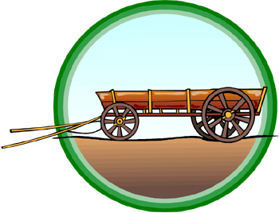
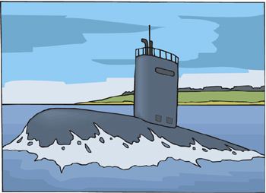
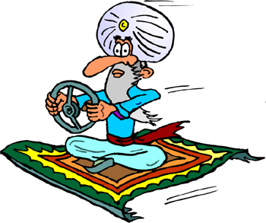. You can position the text box anywhere in the document. Use the Text Box Tools tab to change the formatting of the pull quote text box.]

Motorized | Water | Air | Animal | Rapid | Imaginary

You are going to read a story about the Muslim 14th century traveller, ibn Battuta. Which of the above modes of transportation do you think he used?
2 Try practicing skimming. Match the paragraphs in the text to the main ideas below.

Paragraph A Early Life

Paragraph B Journey to the Far East

Paragraph C Homecoming

Paragraph D The Fame of Ibn Battuta

Paragraph E Working in India

Paragraph F Travels in the Middle East

3 Now answer the questions that follow the text below. Some of them require skimming and some of them require scanning (lesson 3).

1  5  10  15  20  25  30 | A Abu Abdullah Mohammed ibn Battuta was one of the greatest Muslim travellers of all time. He visited almost the entire Muslim world, as well as East Africa, India, Sri Lanka, South-east Asia, and China. In all, he covered more than 117,000 kilometers in his lifetime. That is far more than the distance that Marco Polo, a much more famous explorer, travelled.  B Ibn Battuta was born in 1304 (703 in the Islamic calendar) in Tangier, Morocco. During his childhood years he studied hard and graduated to become a qadi, or judge. At the age of twenty, he decided to complete the Haj, the Muslim pilgrimage to Mecca. Thus began his journey of almost 30 years.  C During his first Haj, ibn Battuta took side trips down the Nile and through Syria and Palestine. Then he decided to visit present-day Iran. At that time much of the land was still under Mongol control, and ibn Battuta met the last of the Mongol leaders, Abu Said.  D After another trip to Mecca, he heard that the new Sultan in India was looking for Muslim scholars to help him build Islam in India. Ibn Battuta decided he would answer the call. He made the trek to India by way of Constantinople (Istanbul) and Central Asia. In India, ibn Battuta served the Sultan for a number of years as a judge. Every day he would sit in court and make decisions about cases. However, the Sultan was a suspicious man, and ibn Battuta started to fear for his life. At his request, the Sultan sent him as an ambassador to China.  E After many adventures, including a shipwreck and an attack by pirates, ibn Battuta reached South-East Asia and from there entered China. He journeyed as far as Beijing, the capital. Then he started the long voyage home.  F Ibn Battuta returned to the Middle East at a difficult time. The Black Death, a fatal disease, was spreading rapidly all over the region. By the time he arrived home in Tangier, both his mother and father had died from it. After two more trips, to Muslim Spain and Mali, ibn Battuta settled down in Morocco in the service of the Sultan there. He worked as a judge and at the same time worked on a book about his travels until his death in 1377. It is from that book that we now know the wonder of ibn Battuta’s life.

i A good title for the passage might be _____________.

(A) Ibn Battuta, Islamic Judge
(B) In the Footsteps of Marco Polo
(C) An Early Muslim Voyager
(D) Travelling in the 14th Century

ii Which one of the following countries did ibn Battuta visit last?

(A) Mali
(B) India
(C) China
(D) Aghanistan

iii What was ibn Battuta’s profession?

(A) traveller
(B) writer
(C) judge
(D) captain of a ship

iv Ibn Battuta probably went to India because __________.

(A) the Sultan asked him
(B) he was very interested in Indian culture
(C) he wanted to help his religion spread
(D) he was a Muslim scholar in that country

v Ibn Battuta decided to leave India because ___________

(A) he was afraid he would be killed.
(B) his ambition was to be ambassador to China.
(C) he was bored working as a judge
(D) he didn’t like to stay in one place for too long.

vi For how many years did ibn Battuta travel?

(A) 10
(B) 20
(C) 25
(D) 30

vii Ibn Battuta had trouble on the way to China because __________

(A) he had to join a group of pirates.
(B) he ended up in South-East Asia instead.
(C) the adventures he planned went wrong.
(D) his boat sank.

viii The parents of ibn Battuta died of

(A) old age.
(B) grief for their son.
(C) a black eye.
(D) a deadly illness.

ix Near the end of his life, ibn Battuta ____________

(A) wrote a book about his travels.
(B) took one last trip to Mecca.
(C) retired from his work as a judge.
(D) shared his memories with a writer.

x The main idea of the last paragraph is _____________.

(A) the Black Death.
(B) the death of ibn Battuta’s parents
(C) the last part of ibn Battuta’s life
(D) ibn Battuta’s career under the Sultan

4 Regular Simple Past verbs in English are usually marked with “ed”. Find 5 regular simple past verbs from the text.

___________________________________________________________

___________________________________________________________

Some Simple Past verbs don’t end in –ed. They are irregular. An example is “was” on line 1. Find the irregular verbs on the following lines of the text:

line 10 ____________________  line 12 ____________________  line 15 ____________________ | line 16 ____________________  line 18 ____________________  line 23 ____________________

Below is a chart with some of the most common irregular verbs. There are some forms missing. Do you know what they are?

Present | Past | Present | Past | Present | Past
become  begin  bite  blow  ________  bring  build  ________  catch  choose  come  cut  do | became  began  bit  ________  broke  ________  built  bought  caught  ________  came  cut  did | drink  drive  eat  fall  _________  find  fly  forget  ________  give  go  grow  hit | drank  drove  ________  fell  felt  found  ________  forgot  froze  gave  went  ________  hit | know  leave  lose  pay  ride  run  say  ________  sell  sleep  ________  win  write | ________  left  lost  ________  rode  ran  said  saw  ________  slept  taught  won  wrote

