Integrated Skills Lesson on Singapore
Singapore Listening Lecture TEACHER COPY

Singapore
Introduction
I am going to talk about Singapore. Singapore is the smallest country in Southeast Asia. It is 137 kilometers north of the equator. It is very close to Malaysia. That is spelt MALAYSIA. It is made up of 63 islands, 63! So you can see there are a lot of islands. The name “Singapore” means “Sea-Lion” in Malay.
Weather
Singapore is a warm place. The temperatures are between 22 °C and 34 °C. June and July are the hottest months. In November and December the weather is very wet and there is a lot of rain.
Economy
Singapore is a rich country. The economy is very good. Tourism is important. Many visitors go shopping in the Orchard Road shopping district. Visitors buy electronics because they are cheap there. Singapore sells computers and petroleum products to other countries.
People
Today, in 2015 there are about 5.5 million people living in Singapore’ that is 5 and a half million people. . About 75% are from Chinese families. 14% are Malays, and about 9% are Indian. Most people speak English.
.
Food
Singapore is famous for its food. Singaporean food is a mix of Chinese, Malay and Indian foods. Seafood is very popular. You can eat many different kinds of food in Singapore, day or night.

- How many islands is Singapore made of?
- What does the word “Singapore” mean?
- What is the weather like in November and December?
- What can you buy in Singapore?
- What is the population of Singapore?
- Which language do most people speak?
- Name on kind of food that you can eat in Singapore.

Singapore Listening Lecture
https://www.youtube.com/watch?v=UydA4Zkk5uw
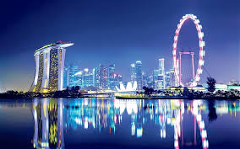TASK: Listen to your teacher talking about Singapore and answer the questions.

- How many islands is Singapore made of?
- What does the word “Singapore” mean?
- What is the weather like in November and December?
- What can you buy in Singapore?
- What is the population of Singapore?
- Which language do most people speak?

Singapore Reading + To Be + Adjectives
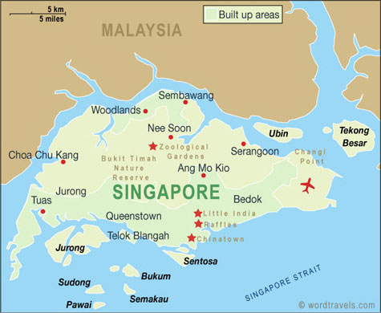
TASK 2: Read the text and add is/am/are
Singapore1. _______ very small. It 2._______ very close to Malaysia. The weather3. ________ hot. Temperatures 4.__________ between 22 and 34 degrees. June and July 5._______ hot months. November and December 6._______ rainy.
Singapore 7._______ not a poor country. The economy 8._______ good. Tourism 9. _______ important. Singapore sells computers and petroleum to other countries.
English 10. _______ popular in Singapore, but the national song of Singapore 11._______ in Malay. The most common second language 12. _______ Chinese.
Singapore 13. _______famous for its food. Singaporean food 14. _______ a mixture of Chinese, Malay and Indian foods. Seafood 15._______ also very popular because Singapore 16.___________ an island so there17. ___________ lots of fish.

TASK 3: Draw a Venn diagram and brainstorm the things that are the same in both countries and the things that are unique to each country.

Only in Singapore | In both countries | Only in the U.A.E
Wet weather in November | Small population  Tall buildings | Dry weather

It is  They are + adjectives | They have  It has + thing | They sell (subject + verb)  It sells (subject + verb + s)
Beautiful  Hot | Small population  Tall buildings  Shopping malls | Sell petrol  Speak English

Comparing Singapore and the United Arab Emirates.
TASK 4: Use the words in the box to complete the blanks below.
It is visit have because are both enjoy wear
Singapore and the United Arab Emirates are very similar. They are 1___________small countries and they both2 _____________ small populations. They both have a lot of islands and a lot of beaches. In addition, both countries 3___________ great weather, but it is usually dry in the United Arab Emirates, while 4 _____ _________ sometimes wet and rainy in Singapore.
Both countries have good economies 5 __________ both countries have petrol. There are many shopping malls in both places and they sell lots of electronics. Both The U.A.E and Singapore have shopping festivals and many tourists 6_________these festivals.
However, Singaporeans are South East Asians and Emiratis 7 __________ Arabs. Singaporeans often 8 ________Chinese style clothes or western clothes, while Emiratis wear kandoras and gutras
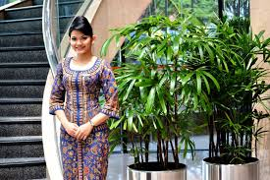.

Comparing Singapore and the United Arab Emirates.
Singapore and the United Arab Emirates are very similar. They are both small countries and they both have small populations. They both have a lot of islands and a lot of beaches. In addition, both countries enjoy great weather, but it is usually dry in the United Arab Emirates, while it is sometimes wet and rainy in Singapore.
Both countries have good economies because both countries have petrol. There are many shopping malls in both places and they sell lots of electronics. Both The U.A.E and Singapore have shopping festivals and many tourists visit these festivals.
However, Singaporeans are South East Asians and Emiratis are Arabs. Singaporeans often wear Chinese style clothes or western clothes, while Emiratis wear kandoras and gutras
.

