NAME: ________________________ ID: _________________________ SECTION: _________
DICTATION - Write the missing words as you hear them
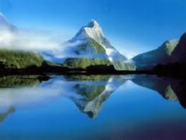
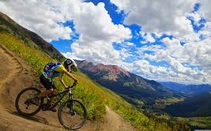
- Every summer, I like to take a ____________ to the mountains where the _______ is fresh and clean. It is very _____________ there because it is __________ away from the city and there are no other people. It is not ___________ at all. I can also ride my _____________ and feel safe because there is no _____________ on the roads.

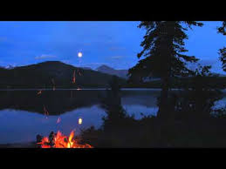
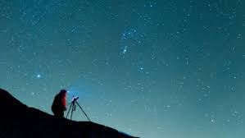
- At night, I like to ___________ a small _____________ to make some tea. I love to look up at the night sky. Sometimes I sit in the ___________ of nowhere and take a ___________ or two. It is my favourite ________ to relax.

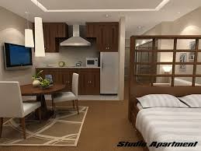
- My normal life is busy. I live in a small ______________ in the __________ of the city. I work in a big _______________ . We sell nice _______________ such as beds and sofas which are beautiful and _________________. Also, they don’t ___________ much money, so a lot of people buy them.
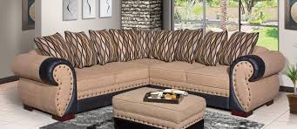
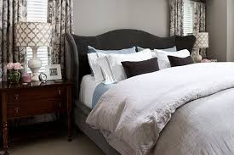

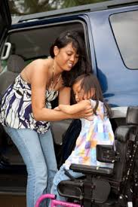
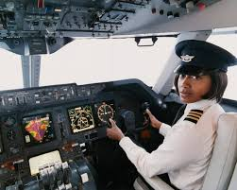
- Usually, when I get ________ work and leave my _____________, I go to visit my family. One of my sisters is a _________________ with British Airways. The other one is a ______________ at a children’s hospital. She is very kind and _________________ with everyone. She is also strong and can __________ the children who cannot walk alone.
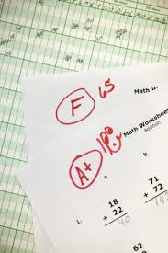
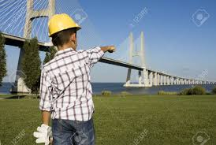
My little brother wants to be an ________________who builds bridges. At school he always gets the top ____________ in math, so he thinks he will like this job.
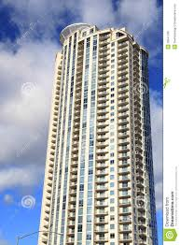

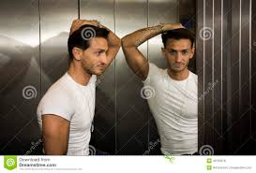
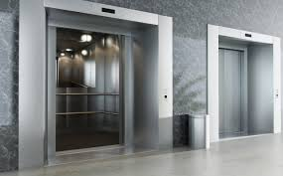
- My family lives in a tall ____________________ building. It is too ___________ to walk to the top so I usually take the ____________. I always check my face in the _____________ on the ________ up, in case my face is _______________ after work.

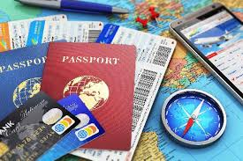
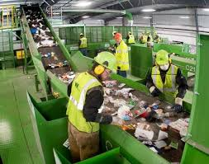
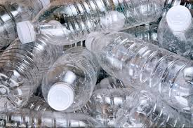
- I bring all my _____________ water bottles there because my brother has started to ______________ them. When he has enough, he will sell them to a recycling ______________ for money. Then he can take a ____________ to the mountains with me next summer. It _____________ a lot of money, so he needs to _______________ many bottles. I wish him good luck!!

