DICTATION - Write the missing words as you hear them
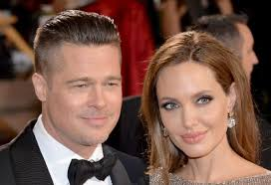
- Brad Pitt is my favourite _______________ and his wife, Angelina Jolie is my favourite ______________________. I think they’re both great!
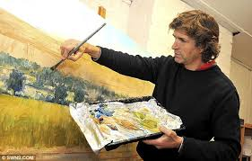
- My brother is a wonderful ___________. He can draw very well.
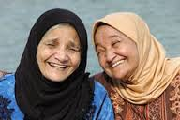
- My _______ Mariam is a very sweet woman. She is the best sister my mother could have.

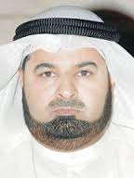
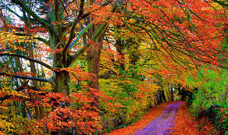
- In Canada, the trees in the ________________ turn beautiful colours such as red, orange, yellow and brown in the _______________. This usually starts in September but in April, when _____________ arrives, the trees all turn green again.

- My _________ Ali is a great _______________________. He studied at HCT and now owns three companies here in the UAE.
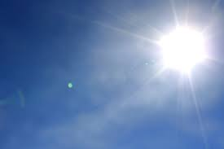
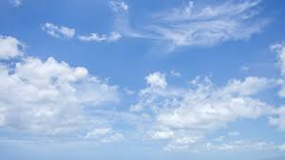
- Some people like it when the ________ is _____________ and blue but others prefer it when it is a little _______________. That means the sun is not too strong.
- When there are lots of _______________ in the _________, the weather is a bit ____________ too and that’s a good thing!
- My _____________ Hamad is a great _________________ and _____________. He loves music and is always popular at parties.
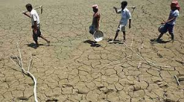
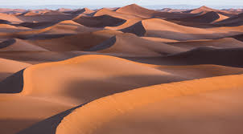
- Not many things grow in the _____________________ because it is so _________. It is not a great place for _________________ to work!

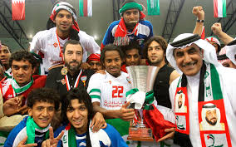
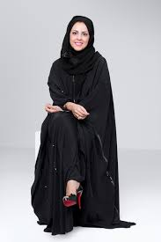
- Every day after class, I go to practise at my local football ______________, even if we don’t have a _______________. We work hard because we want to _________ the trophy this year! Football is my number one ___________.

- My _________ Fatima is studying _________________ design at university. She loves clothes and will become a _________________ when she finishes her studies.

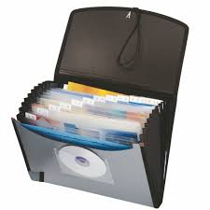
- I keep all the papers and _______________________ my teacher gives me in a special ______________ so I can find it easily.

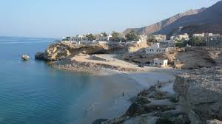
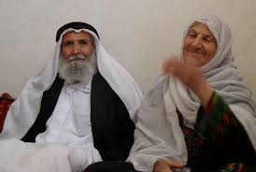
- My ____________________ and _______________________ live on a small _________________ off the coast of Fujairah. We have to take a boat when we go to visit them.
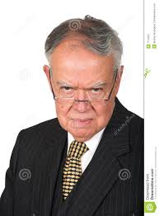
- My _________________ always has a very serious face. I don’t think he knows how to _______________! It’s not fun to work for him!
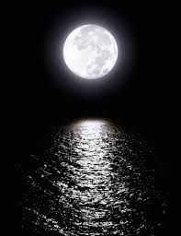
- I love to sit on the beach at night and look up at the _________ - especially when the ___________ is full and bright! It’s just beautiful!

