DICTATION - Write the missing words as you hear them
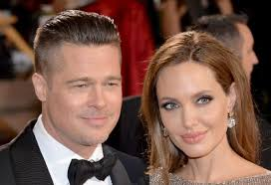
- Brad Pitt is my favourite ____actor_______ and his wife, Angelina Jolie is my favourite _____actress_____. I think they’re both great!
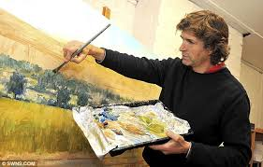
- My brother is a wonderful ____artist_______. He can draw very well.
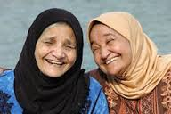
- My _____aunt Mariam is a very sweet women. She is the best sister my mother could have.

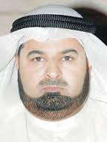
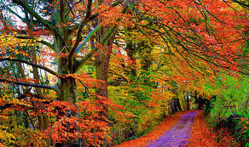
- In Canada, the trees in the ________forest___ turn beautiful colours such as red, orange, yellow and brown in the _____autumn______. This usually starts in September but in April, when ____spring_____ arrives, the trees all turn green again.

- My ___uncle__ Ali is a successful _____businessman__________. He studied in America and now owns three companies here in the UAE.
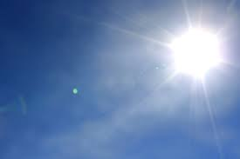
- Some people like it when the __sky ____ is ___clear_____ and blue but others prefer it when it is a little ____cloudy_____. That means the sun is not too strong.
- When there are lots of ___clouds_______ in the __sky____, the weather is a bit ____cool_____ too and that’s a good thing!
- My ____cousin____ Hamad is a great ____dancer_______ and _____singer____. He loves music and is always popular at parties.
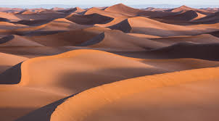
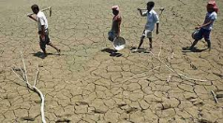
- Not many things grow in the _______desert________ because it is so ___dry___. It is not a great place for ____farmers______ to work!

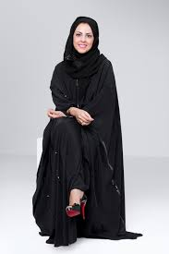
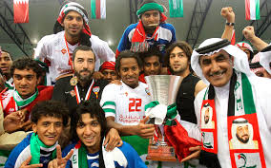
- Every day after class, I go to practise at my local football _____club______, even if we don’t have a ____match______. We work hard because we want to ___win___ the trophy this year! Football is my number one ____hobby___.

- My ___cousin___ Fatima is studying ______fashion____ design at university. She loves clothes and will become a ___businesswoman____ when she finishes her studies.

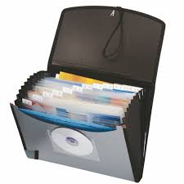
- I keep all the papers and __information__________ my teacher gives me in a special __file________ so I can find it easily.

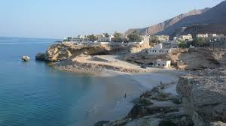
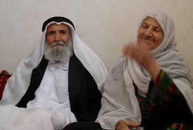
- My __grandmother_______ and ___grandfather_________ live on a small _____island______ off the coast of Fujairah. We have to take a boat when we go to visit them.
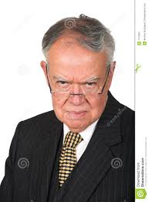
- My ____manager______ always has a very serious face. I don’t think he knows how to ___laugh_______! It’s not fun to work for him!
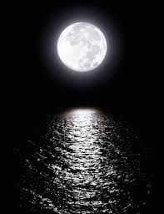
- I love to sit on the beach at night and look up at the ___sky___ - especially when the __moon_____ is full and bright! It’s just beautiful!

