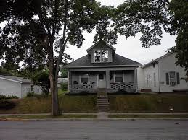
DICTATION - Write the missing words as you hear them
- My brother lives in the house ____________ the street from me. I can talk to him every day!
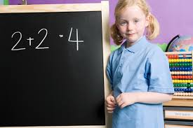
- My little sister knows how to ________. She knows that 2 + 2 = 4! It is _____________ math!
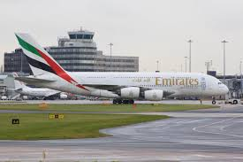
- We must arrive at the ________________ by 10:00 pm. Our plane leaves at midnight.

- That dog is crazy! He is chasing his own tail _________________ and ________________!

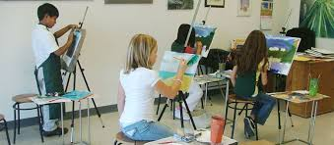
- I want to study ___________ and design in college. I don’t like science or math very much. I want to ______________ a famous artist in the future.
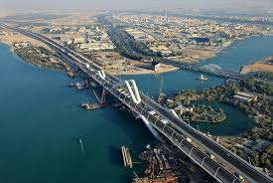
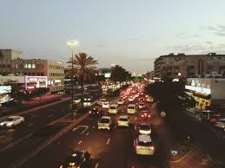
- It is best to go ______________ Sheikh Zayed __________________ to get to Khalifa City A because the Airport Road is too ________________ in the evening.
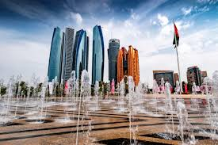
- Abu Dhabi is the ___________________ city of the UAE. You must write ‘Abu Dhabi’ with two _________________ letters because it is the name of a city.
- You must eat _________________ food and give your body ______________ to have good ___________________. It’s important for life.
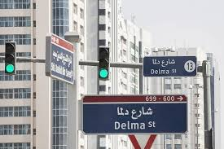
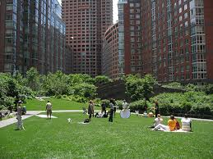
- To find my house, you must _________________ Delma Street to Muroor Road. First ____________ right, then ___________. My house is in ____________________ of a small park, __________________ the bank.
- I cannot eat one more thing! I ate six hamburgers and now I am ____________!

- If you think the _____________ of books is too high, you should visit the __________________. There, you can read books for free!

- I like to ___________________ to ________________ on the street when I see them visiting my city. I can help them learn about the place.
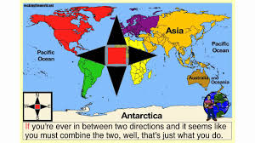
- In the past, people used a paper _____________ to know which direction to ______________________. It shows __________________, ___________________, _____________________ and ______________. Today, most people just use a GPS.

- My summer house is beautiful! It is on a high ______________________ where the air is cool and near a __________________ where we can swim.

