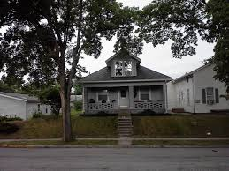
DICTATION - Write the missing words as you hear them
- My brother lives in the house ___across___ the street from me. I can talk to him every day!
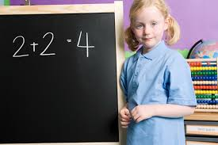
- My little sister knows how to __add___. She knows that 2 + 2 = 4! It is ____simple_____ math!
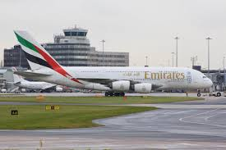
- We must arrive at the _____airport________ by 10:00 pm. Our plane leaves at midnight.

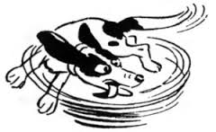
- That dog is crazy! He is chasing his own tail ____around_______ and ___around______!

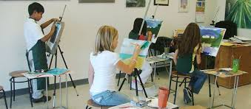
- I want to study ___art_____ and design in college. I don’t like science or math very much. I want to ____become___ a famous artist in the future.
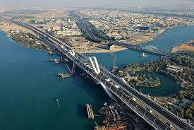
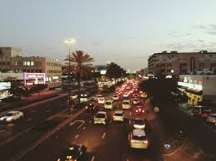
- It is best to go ____over______ Sheikh Zayed ____Bridge_______ to get to Khalifa City A because the Airport Road is too ____busy_______ with traffic in the evening.
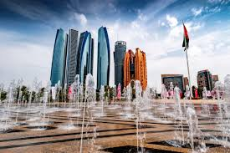
- Abu Dhabi is the ____capital________ city of the UAE. You must write ‘Abu Dhabi’ with two ___capital________ letters because it is the name of a city.
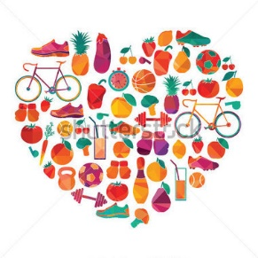
- You must eat ____healthy______ food and give your body ___exercise___ to have good ____health_________. It’s important for life.
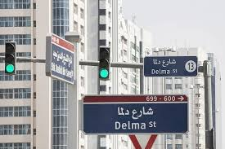
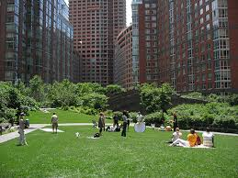
- To find my house, you must ___follow________ Delma Street to Muroor Road. First ____turn____ right, then __left_____. My house is in ___front____________ of a small park, ___opposite________ the bank.
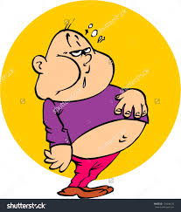
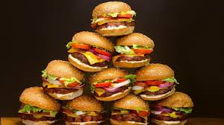
- I cannot eat one more thing! I ate six hamburgers and now I am ___full_____!

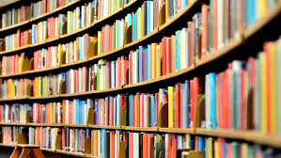
- If you think the ____price____ of books is too high, you should visit the ___library________. There, you can read books for free!

- I like to ______chat_________ to ____tourists____ on the street when I see them visiting my city. I can help them learn about the place.

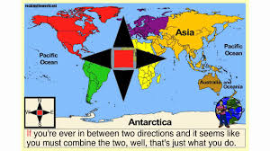
- In the past, people used a paper ___map_______ to know which direction to _____follow__________. It shows ___north___________, _______south_______, _______east__________ and __west____________. Today, most people just use a GPS.

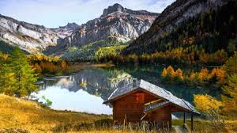
- My summer house is beautiful! It is on a high ______mountain________ where the air is cool and near a _____lake_________ where we can swim.

