Name: ______________________________ Section: _____________ Date: _______________
Write the words as you hear them to complete the paragraphs.
ACTIVITIES

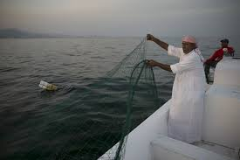
What do you like to do in your free time?

Some people like to go ____________________ in the sea but my favourite ___________ is _______________ in the desert.
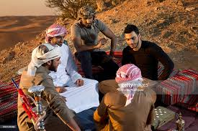
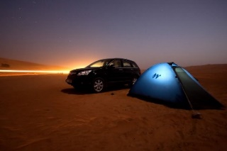
Sometimes I go ___________but __________I ___________ my friends. _______________ ___________ a tent for sleeping.
My tent is an ______________one and I was happily ____________________ that it did not cost too much money!
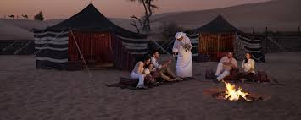
We go to the desert to enjoy ____________. Camping is a __________hobby in the UAE. _________________ you look, you can see people ___________ in tents and sitting by the campfire.
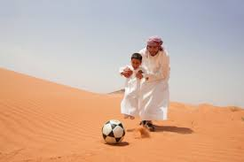
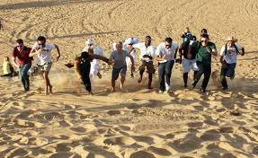
You can also find us playing football in ____________ or _____________ _____________.

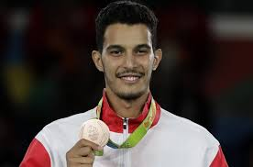
_____________ wants to be in ______ place and win a ________. This is especially _________ for my brother. He doesn’t like to ________ at anything he does.
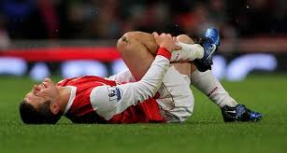
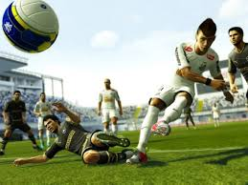
I am not ________________ the ____________ because I don’t ________ quickly. In football, I am afraid that ___________ player will _______ me and I will _______ down or be in ________.
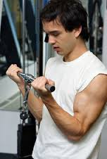
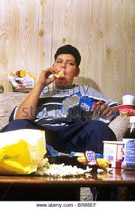
I think I need to exercise more. This will also make my _________ _________ and I can become ________ again.
Last year I became too fat because I didn’t _________ very much or do any kind of _____________after school – only watch TV and ____________ on my sofa every day.
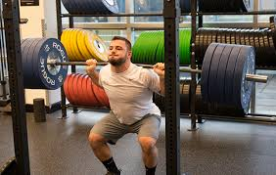
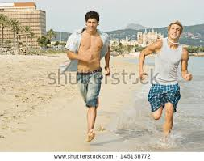
Maybe this year, I will ________________ __________________ in my family and __________ the gym so I can become even faster than my brother!

