NAME: _____________________ ID: ____________________ DATE: ___________
DICTATION - Write the missing words as you hear them
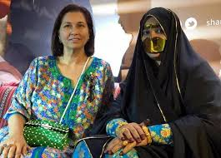
- My _______ Aisha is a very lovely woman. She is the best sister my mother could have. She is __________________ to my _____________ Ali.

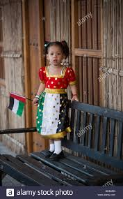
- They have only one son. He is my _____________, Hamad. He is a great ________________ and is always popular at parties.

- Hamad has two sons and one daughter, Miriam. She is the only _________________ for Aisha and Ali. They love being the ______________s of these three children.

- In the UAE, some people like to see a ______________ _________, but others like it when they see a _________ _____________s. They hope it will soon rain.
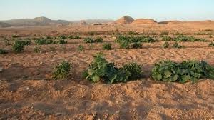
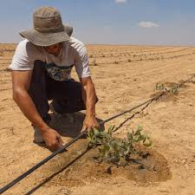
- The rain is good because this is a very _________ country. It is not an easy place to be a _______________!

- Do you like to sit on the beach at night and look up at the ___________ when it is full and bright? I do! It’s just beautiful!

- My ______________ and her business _____________ always look very serious. They never _______________ or have fun, but their ________________ is always smiling and happy! I like working with her!

- When I went to my first ____________________ with my ________________, he asked me to ______________ my _____________ twice. He had not heard the name ‘Aljeneibi’ before, because he is not from this country.

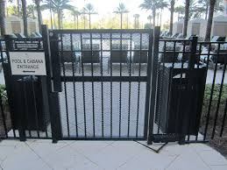
- In my __________________, you need to open the _______________ to get to the _____________ pool.
- Every day after college, I go to practise at our local football ______________, even if we don’t have a match. Football is my number one ___________.
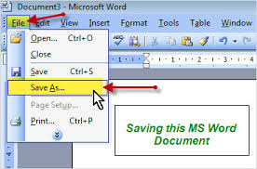
- Please ___________ the ___________and save it as a PDF on your laptop or make a paper ____________ to study later.

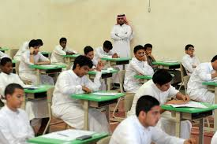
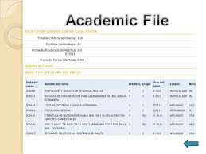
- If you _____________ from another student in your college exam, you will get a yellow or red ______________ and your name will go on _______________ in the office for cheating. You may even get kicked out of college! Don’t do it!!

