Collocations – basic
- Write the words from the box in empty spaces to complete the phrases. Use each word only as many times as it is in the box, make sure that all words are used:
get get go go go have have have have come iron watch buy do listen read

- ______________ the laundry
- _______________ up
- _______________ dinner
- _______________ to bed
- _______________ TV
- _______________ home
- _______________ breakfast
- _______________ to work
- _______________ a book
- _______________ to music
- _______________ a shower
- _______________ shopping
- _______________ a newspaper
- _______________ the clothes
- _______________ dressed
- _______________ lunch

- Now match the complete phrases with the pictures below, write the correct letter next to each picture.

1. 2. 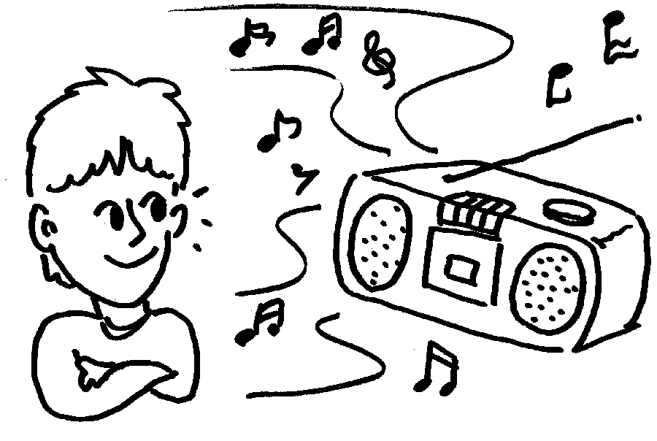 3. 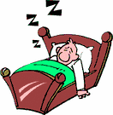 4.
5. 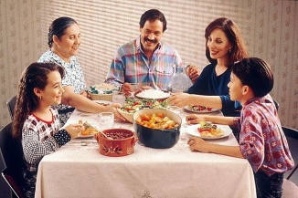 6. 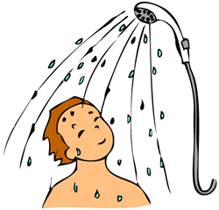 7. 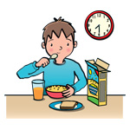 8. 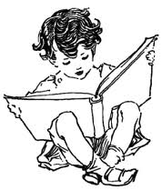
9. 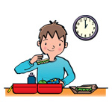 10. 11. 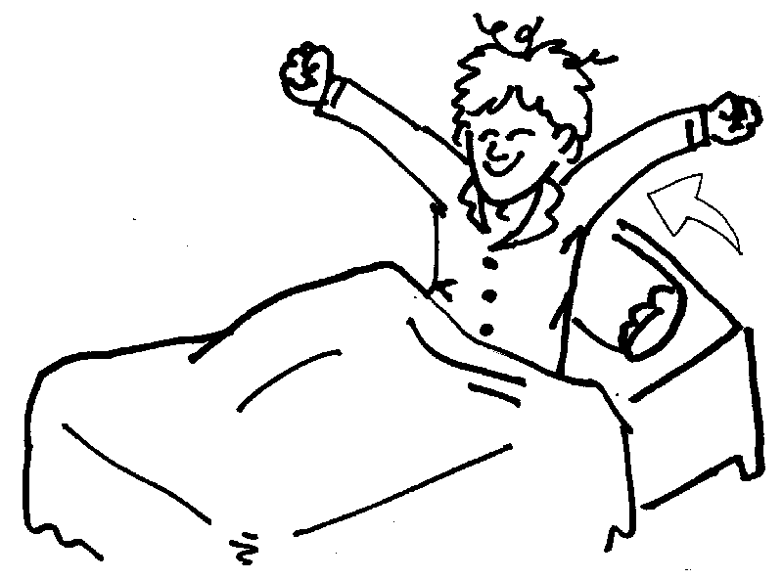 12.
13. 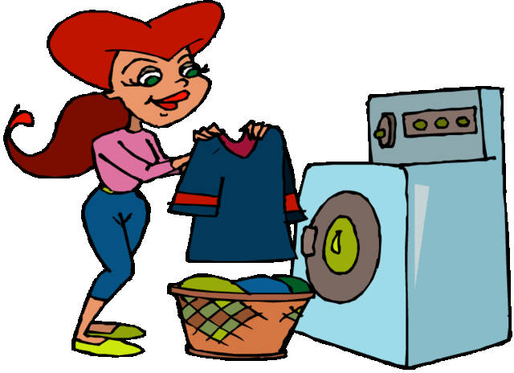 14.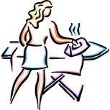 15.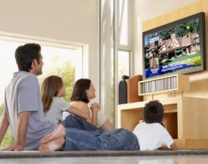 16.

Now look at the example sentences:
- 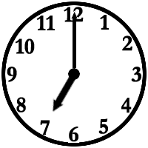 I get up at seven o’clock.
- 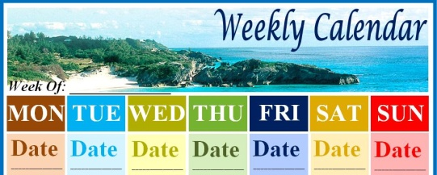 I iron the clothes on Tuesday.

Now complete the remaining examples yourself. Use ‘I’ to start a sentence.
- 










