Grammar: Past Tense

Past Tense of “BE”
time or location
Subject + was/were + adjective
noun

+ | I/He/She/It _____ ______ late. | We/you/they ____ _______ late.
- | I/He/She/It ___ ________ a student last year. | We/you/they __________ students last year.
? | _____ I/he/she/it home when you arrived? | _________ we/you/they home when you arrived?

Past Tense with Action Verbs (STUDY)

+ | I/He/She/It  _____________ last night. V2  We/you/they
- | I/He/She/It  __________ __________ last night.  We/you/they
? | I/He/She/It  ______ _________ last night?  We/you/they

When do you use “did” in the past tense? _______________________

Remember! Some verbs are irregular (do not end in “ed”)

say ___ make ___ become ___

see ____ write ___ be born _______

eat ___ drive ___ get married ___ ________

wake ___ have ___ tell ___________

get ____ take ___________ come ___________
Writing: Spelling Rules for Past Tense
Part 1. What are vowels? __a, e, u, o, i____
What are consonants? _b, c, d, f, g, h, t, z ……….._

Part 2. Past Tense Spelling Rules
Verb | Rule | Example
Most regular verbs | Add –ed | watch → WATCHED  start→ STARTED
Ends in one e-- | Add d | hate→ HATED  love→ LOVED
Has one syllable and it  ends in consonant + vowel + one consonant (CVC) | Double last letter  Add -ed | stop→ STOPPED  tip→ TIPPED
Ends in consonant + y (C+y) | Y – I  ED | carry → CARRIED  worry → WORRIED  play → PLAYED

Write the past tense of these regular verbs.
end _____ warn ____
visit ___ finish ___
stay ____ pray __
try ____ explore ____

Now read the story.

\Correct all of the spelling mistakes. There are 6.
Correct all of the grammar mistakes. There are 6.

The Gift
A few years ago, my friend rememberd that it is her mother’s birthday, so she quickly walked to a pet shop to get something for her. She found a beautiful parrot that speaks several foreign languages. The bird is quite expensiv – over 5,000 dirham! My friend does not has much money, but she wants to make her mother very happy so she bought the bird. She thought her mother would enjoy the gift very much. She wraped the bird in its cage, Later and askd a man to deliver it to her mother. that day, my friend calld her mother. “How do you like your gift?” my friend asked. “I tryed it as soon as I get it! It is delicious!” her mother answerd.
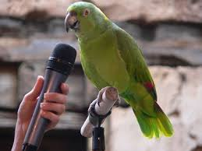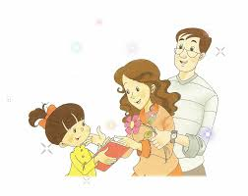

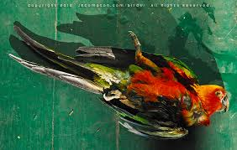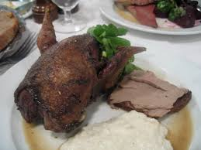
Organizing a Story
Can you complete the missing parts?

Situation: | ______________ mom’s birthday
What happened first? | Walked to _______________  ______________ parrot that spoke many languages
What happened next? | Sent ______________ to mother
What happened later? | I _______________ my mother  Mother said she _____________ bird!

Now think of a story you can tell.
- Your story can be happy, funny, sad or simply interesting. It does not have to be true.
- You can tell about yourself, a friend or about someone famous. You can use your own idea or one of these:
My First Car Accident My First Day at HCT
How I Won the Lottery In Trouble!
Scared in a Foreign Place How I Learned to….
The First Time I …. A Crazy Day

- Write NOTES about the KEY EVENTS in your story
Situation:
What happened first?
What happened next?
What happened later?

2. Tell your story to two people.

Writing Practice: Write the same story here.
Remember! Use Past Tense Verbs & Organizing Words

_______________________________

_______________________________________________________________________________________________________________________________________________________________________________________
____________________________________________________________________________________________________________________________________________________________________________________________________________________________________________________
____________________________________________________________________________________________________________________________________________________________________________________________________________________________________________________
____________________________________________________________________________________________________________________________________________________________________________________________________________________________________________________
____________________________________________________________________________________________________________________________________________________________________________________________________________________________________________________

