Singapore Listening Lecture
https://www.youtube.com/watch?v=UydA4Zkk5uw
TASK: Listen to your teacher talking about Singapore and answer the questions.

- How many islands is Singapore made of?
- What does the word “Singapore” mean?
- What is the weather like in November and December?
- What can you buy in Singapore?
- What is the population of Singapore?
- Which language do most people speak?

Singapore Grammar Exercise + To Be + Adjectives
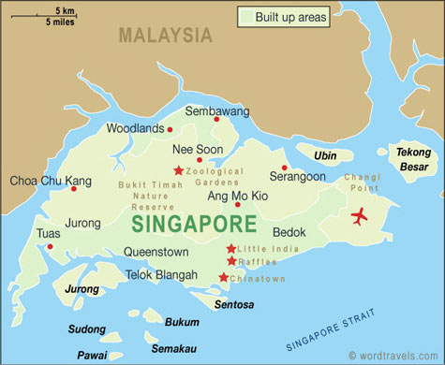
TASK: Read the text and add is/am/are
Singapore1. _______ very small. It 2._______ very close to Malaysia. The weather3. ________ hot. Temperatures 4.__________ between 22 and 34 degrees. June and July 5._______ hot months. November and December 6._______ rainy.
Singapore 7._______ not a poor country. The economy 8._______ good. Tourism 9. _______ important. Singapore sells computers and petroleum to other countries.
English 10. _______ popular in Singapore, but the national song of Singapore 11._______ in Malay. The most common second language 12. _______ Chinese.
Singapore 13. _______famous for its food. Singaporean food 14. _______ a mixture of Chinese, Malay and Indian foods. Seafood 15._______ also very popular because Singapore 16.___________ an island so there17. ___________ lots of fish.

