1 Family
Family Part 1

- Do you have a big or small family?
- How many brothers and sisters do you have?
- What number child are you in your family?
- What do your parents do?
- How do you spend your time with your family?

Family Part 2
Examiner: In some families, young people do work at home to help their parents. Which jobs do you think teenagers can do? Decide together the best types of work that young people could do at home.
Here are some pictures to help you. [Discuss each picture]

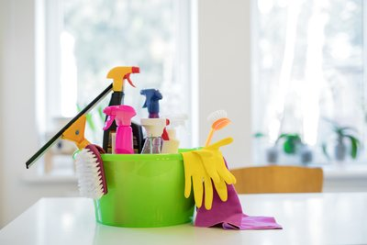 | 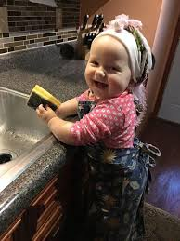 | 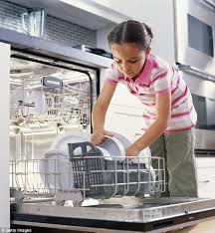 | 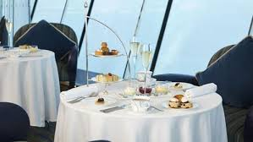
 |  | 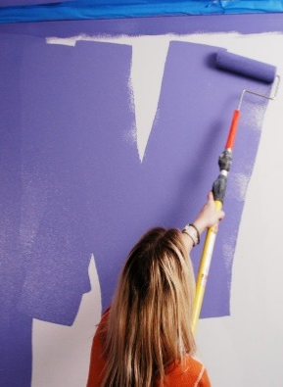 | 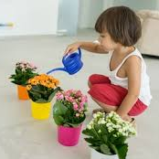

2 Home
Home Part 1

- Where is your home?
- Do you live in a house or an apartment?
- Who do you live with?
- How many rooms are there in your house?
- What is your favorite room? Why?

Home Part 2
Examiner: Your college wants to have a room where Communication students can relax when they are free. What would you like to have in this room? Decide together what furniture and decoration are best for this room.
Here are some pictures to help you. [Discuss each picture]

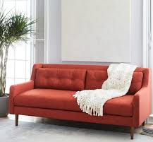 | 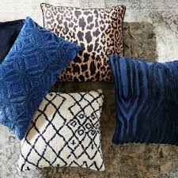 | 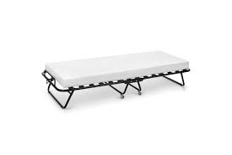
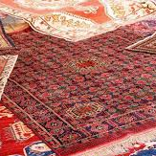 | 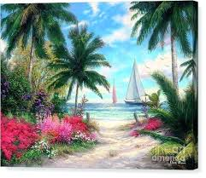
3 Daily Routine
Routine Part 1

- When do you usually wake up?
- What do you do first thing after you wake up?
- How do you spend your time at college?
- What do you usually do at night?
- When do you go to bed during the week?

Routine Part 2
Examiner: Mariam and her husband are both doctors at Khalifa Hospital. Their work routine is difficult and stressful, so they need some relaxation activities after work and at weekends. Decide together on the best ways for them to relax.
Here are some pictures to help you. [Note: Discuss each picture]

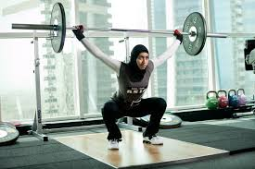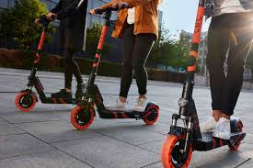

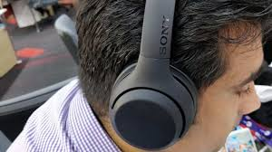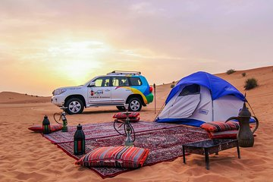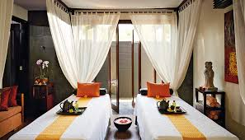

4 Neighborhood
Neighborhood Part 1

- Where do you live?
- Do you like the place you live in?
- What can you find in your neighborhood?
- Do you visit your neighbors?
- If yes, who is your favorite neighbor? If no, why not?

Neighborhood Part 2
Examiner: Mariam and Abdulla have just got married, and they are choosing where to live. They want to choose an area that is comfortable to live in. Decide together what their neighborhood should have. Here are some pictures to help you. [Note: Discuss each picture]

 |  | 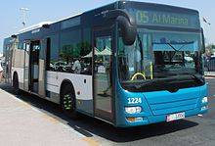 | 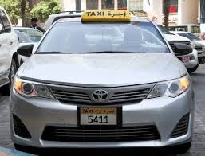
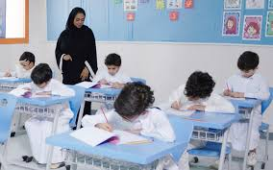
5 Friends
Friends Part 1

- How many close friends do you have?
- Who is your favorite friend?
- Why do you like her?
- What do you do together?
- Why are friends important?

Friends Part 2
Examiner: A friend in your class has a birthday next week. You want to buy her a gift that she will like. Decide together what a good gift for your classmate would be.
Here are some pictures to help you. [Note: Discuss each picture]

 | 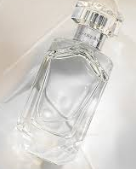 | 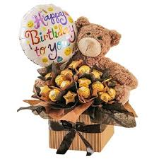 | 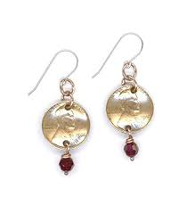
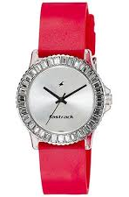 | 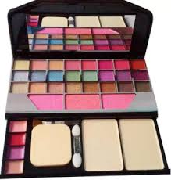 |  | 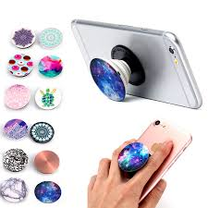

6 Food
Food Part 1

- What is your favorite food?
- What is it made of?
- When do you usually eat it?
- Who do you usually have this food with?
- Do you like any other dishes?

Food Part 2
Examiner: You are planning a surprise party for a friend. You are going to order some food and drink. You want food that is delicious, but also quite healthy. Decide together on a suitable menu.
Here are some pictures to help you. [Note: Discuss each picture]

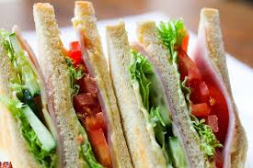 | 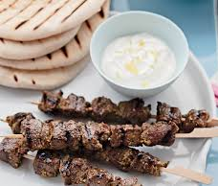 | 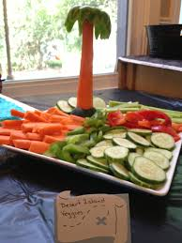 | 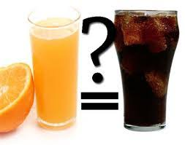
 | 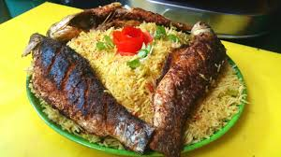 | 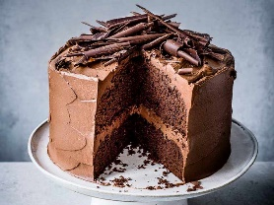 | 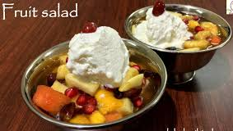
7 Hobbies
Hobbies Part 1

- What do you like doing in your free time?
- What is your favorite hobby?
- Why do you like it?
- When do you do it?
- Is there anyone you share your hobby with?

Hobbies Part 2
Examiner: Your college is planning extra classes in different activities and skills for students who are interested. Decide together which activities are interesting for students in our college.
Here are some pictures to help you. [Note: Discuss each picture]

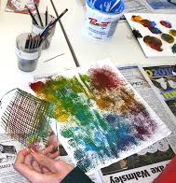

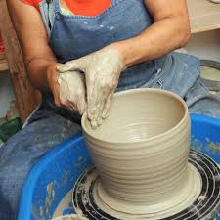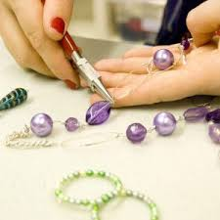
8 Sports
Sports Part 1

- Do you like to do sports?
- What is your favorite type of sports?
- How often do you exercise?
- Where do you exercise?
- In what ways is sport good for our health?

Sports Part 2
Examiner: Many people think that some sports are better for boys to play than for girls. What do you think? Decide together which sports may be interesting for students in our college.
Here are some pictures to help you. [Note: Discuss each picture]

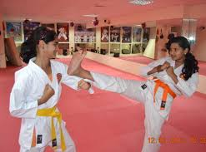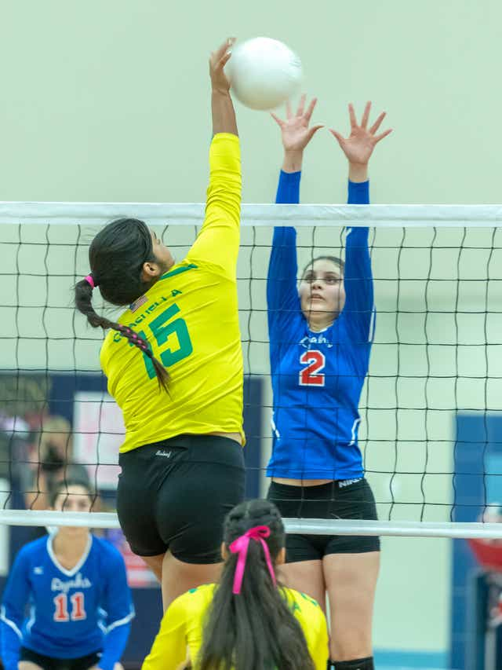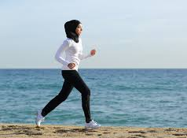

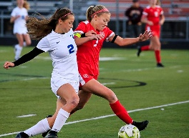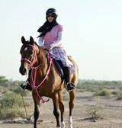

9
Travel Part 1
- Do you like to travel?
- Who do you like to travel with?
- Where do you usually travel to?
- What do you usually do when you travel?
- Where do you want to go next?

Part 2
Examiner: Imagine your class is going on a trip to another country. You can choose interesting activities to do on the trip. Decide together which activities are best for your class.
Here are some pictures to help you. [Note: Discuss each picture]

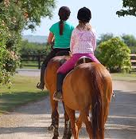 | 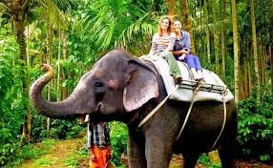 | 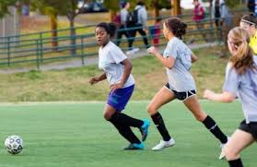 | 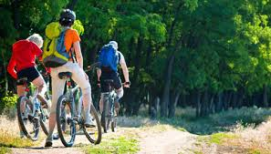
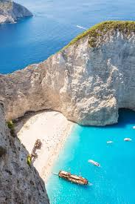 | 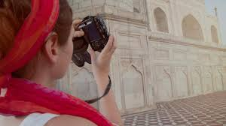 | 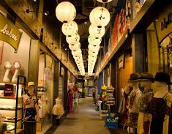 | 