STUDY LADDER: Reading and Spelling Support
How teachers can get into Study Ladder
Go to https://www.studyladder.com Login using dozdeniz@hct.ac.ae Password: english
(At present everything is set up for us)
Students have been added in classes
Passwords have been shared with you and printed
Materials have been selected
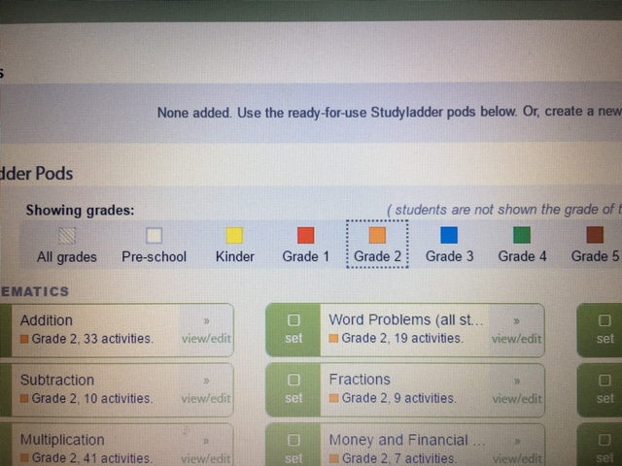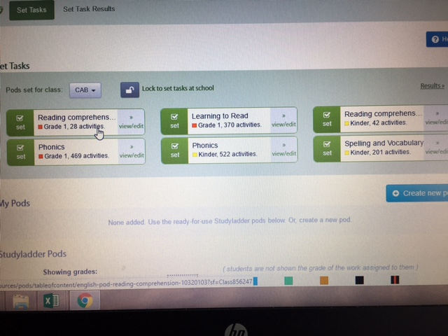
Teachers can explore the website as a student using the dummy login –
username: tea8462
password: jelly
As a teacher you can see student passwords and their scores.
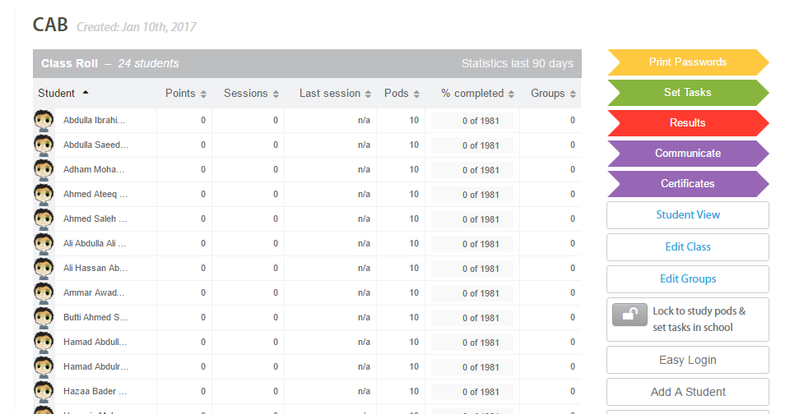
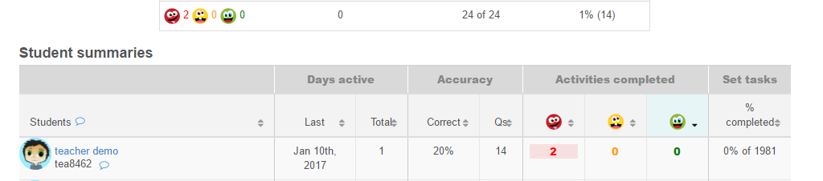
How to get students into Study Ladder
- Go to https://www.studyladder.com
- Login using your Study Ladder username and password e.g. username: Moh8462 password: red
3.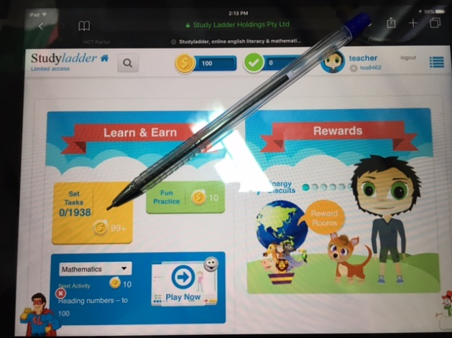 Tap on the yellow square Set Tasks.
4. 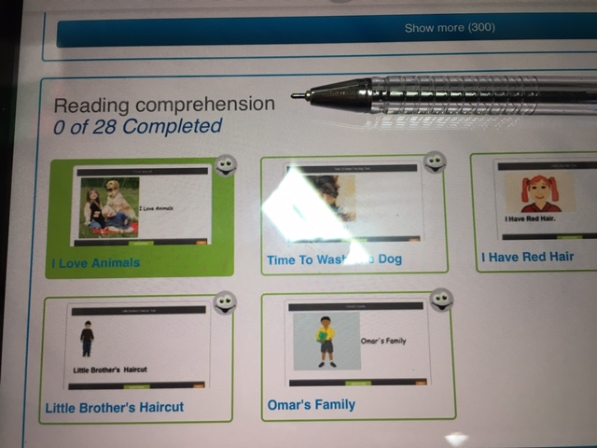
Go to Reading Comprehension (easier) or Reading for Knowledge (more difficult).
5.
Read, then answer the questions.
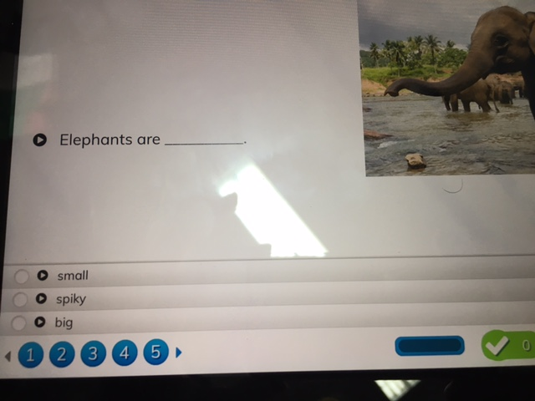
6. 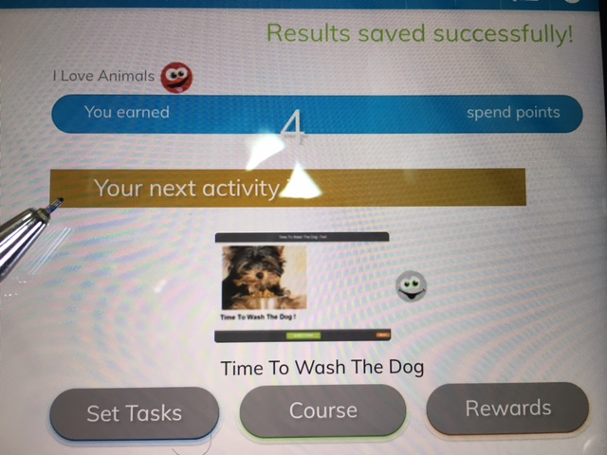
Tap on next activity to continue.

7. Tap on the house icon to go back to your home page.

8. Your teacher can see your scores

