Listening: The Empty Quarter or Rub- Al Khali
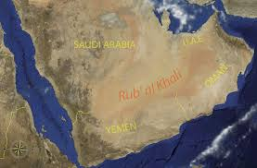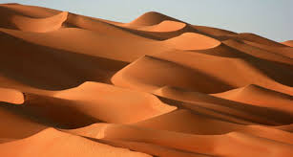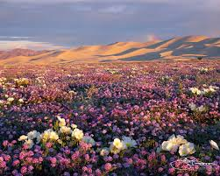
- Listen and fill in the gaps below:

- Most people think The Empty Quarter is a typical desert because it is hot,_____________ and has lots of _____________.
- Some of the sand dunes are ___________ tall.
- The temperatures in The Empty Quarter go as high as ________ in summer.
- The Bedouin travelled to the ___________ in the summer.
- There are also strong ___________ in the desert.
- There is not a lot of ___________ but sometimes there can be a big ________________.
- After heavy rain, the desert can look like a big __________ because there are lots of _________ and ______________.
- Discussion Point: After listening tell a partner what you like to do in the desert.

