Adjectives (1)
Adjectives are words that describe nouns. Adjectives make nouns more interesting.
A bird -> A big red beautiful bird
My car -> My old, dirty car
This story -> This story is short and funny.
I am (I’m) | big  small  short  tall  fun  boring  clean  dirty | easy  hard  old  young  nice  mean  fast  slow
He is (He’s)
She is (She’s)
It is (It’s)
They are (They’re)
You are (You’re)
We are (We’re)

TASK ONE: Circle the adjectives in these sentences.
1. This car is new.

2. She is a funny girl.

3. John is tall, but Jane is short.

4. The new car is very clean.

5. The fast car drove past the slow truck.

6. Playing baseball is tiring in hot weather!

7. Your book is so dirty! It is not clean!

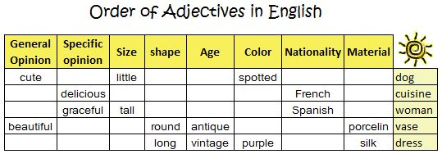
http://dictionary.cambridge.org/us/grammar/british-grammar/adjectives-order

TASK TWO: Describe the things in each picture. Use three adjectives in each sentence.
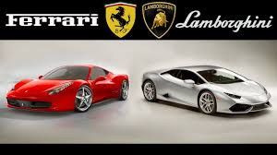
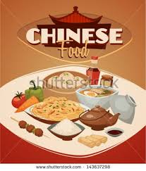
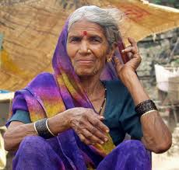
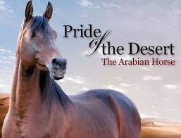

Write a paragraph about Salem : Add Details to Your Description

a. name: Salem Ali ( successful/ Emirati/ family man)
b. age: 45
c. job: manager (friendly/ popular/ site/ marketing/ financial )
d. place of work: GASCO
e. married/single: married ( happily )
f. children: 5 children (lovely /healthy/ young)
g. home: villa-Abu Dhabi ( beautiful/modern/ large/ small/ Arabian )
h. hobbies: fishing, watching movies, ( favourite/ usually/ once a week)
i .languages: Arabic, English ( perfect/ basic)
j. car: ( beautiful/ new/ Land Cruiser )

----------------------------------------------------------------------------------------------------------------------------------------------------------------------------------------------------------------------------------------------------------------------------------------------------------------------------------------------------------------------------------------------------------------------------------------------------------------------------------------------------------------------------------------------------------------------------------------------------------------------------------------------------------------------------------------------------------------------------------------------------------------------------------------------------------------------------------------------------------------------------------------------------------------------------------------------------------------------------------------------------------------------------------------------------------------------------------------------------------------------------------------------------------------------------------------------
----------------------------------------------------------------------------------------------------------------------------------------------------------------------------------------------------------------------------------------------------------------------------------------------------------------------------------------------------------------------------------------------------------------------------------------------------------------------------
----------------------------------------------------------------------------------------------------------------------------------------------------------------------------------------------------------------------------------------------------------------------------------------------------------------------------------------------------------------------------------------------------------------------------------------------------------------------------
----------------------------------------------------------------------------------------------------------------------------------------------------------------------------------------------------------------------------------------------------------------------------------------------------------------------------------------------------------------------------------------------------------------------------------------------------------------------------
--------------------------------------------------------------------------------------------------------------------------------------------------------------------------------------------------------------------------------------

Online Exercises
http://web2.uvcs.uvic.ca/elc/studyzone/410/grammar/adjord1.htm
file:///C:/Users/dozdeniz/Documents/1%20level%20FIP/week%203%20spres%20questions%20lifestyle%20U%203&4/Writing/atg-scrabgame-adj.pdf
http://www.allthingsgrammar.com/uploads/2/3/2/9/23290220/atg-worksheet-adjpeople.pdf
http://www.allthingsgrammar.com/adjectives-and-adverbs.html

