

***Writing***

***EmSATdirect***

***Writing:*** *descriptions of objects, people, places, times*

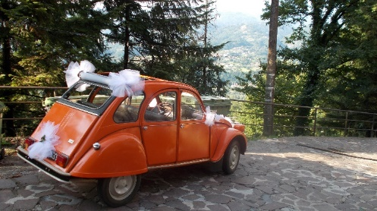**Writing a *description***

|  |
| --- |
| **Description questions**  **For some EmSAT and Level 1 writing questions, you have to write an essay *describing* something in your life.**  **It may be a *person*, an *object*, a *place*, or a *time*.**  **Example questions**   * *Describe something you have.* * *Describe your best friend.* * *Describe your daily routine.* * *Describe your home.* |

1. **Write P (person), O (object), Pl (place), or T (time) by the *description* questions.**

* Describe a day in your life when you were very happy.
* Describe something you own that you really love.
* Write a description of a member of your family.
* Describe a city or town you know well.

**Describing an object**

1. **Think about your mobile phone and answer questions 1 - 3.**

|  |  |  |  |
| --- | --- | --- | --- |
| **1** | Is it important to you?  How did you get it? | |  |
| **2** | What will you do with it in the future? | |  |
| **3** | Was it expensive?  What does it look like?  When do you use it?  Where do you keep it? |  | |

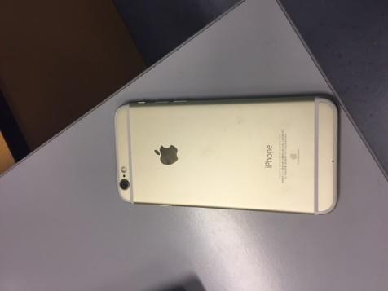**Describe an object you**

**own that is important to you.**

|  |
| --- |
| 1. In this essay, I am going to describe my phone. I chose this phone to write about because it is my favorite possession. My parents gave it to me last year. 2. It is an iPhone, and it is very expensive. It costs about 3,000 dirhams. It is made of plastic, metal and glass, and it is silver and black. It has a lot of functions, and it is very thin and light. I think it is very beautiful. I use my iPhone every day for social media. At college, I use it to look up vocabulary and play Kahoots. I keep it in my bag or my pocket. 3. In conclusion, I love my phone. I will keep it until there is a new iPhone, and then I will give it to my little brother. *135 words* |

1. **Match questions 1 – 3 in *exercise 2* with paragraphs *A – C* in the essay above. Were your answers the same or different?**
2. **Answer questions 1 – 12. Which paragraph (P) *A – C* gives you the answers?**

|  |  |  |  |
| --- | --- | --- | --- |
|  | **question** | **answer** | **P** |
| **1** | Does the writer think it is beautiful? |  |  |
| **2** | Who bought it? When? |  |  |
| **3** | Where does she keep it? |  |  |
| **4** | How much does it cost? |  |  |
| **5** | What make/brand is it? Is it expensive? |  |  |
| **6** | What does it have? Is it big/heavy? |  |  |
| **7** | Why did she choose to write about it? |  |  |
| **8** | When does she use it? |  |  |
| **9** | What is it? |  |  |
| **10** | What will she do with it in the future? |  |  |
| **11** | What is it made of? What colors is it? |  |  |
| **12** | Overall, what does she think about it? |  |  |

**Vocabulary for describing objects**

|  |
| --- |
| **Vocabulary for your things**  **Noun: *possession***   * **My favorite *possession* is my car.**   **Verbs: to *have* something / to *own* something/ to *belong to* someone**   * ***I have two watches*** * ***I own two watches.*** * ***This watch belongs to me.*** |

1. Choose the correct word to complete the sentences.
2. I ***own / belong*** a new car.
3. I have many ***owns / possessions*** that I love.
4. Do you ***have / belong*** a calculator?
5. Who does this laptop ***belong / own*** to?
6. **Complete the table below with the *description* words from the box.**

|  |
| --- |
| **white wool metal purple attractive silk cheap huge thin glass orange stylish beautiful** |

|  |  |  |  |  |
| --- | --- | --- | --- | --- |
| **color** | **material** | **price** | **size /weight** | **appearance** |
| blue |  | expensive |  |  |
| black | wood |  | light | nice |
| green | gold | good value | small | ugly |
|  |  | precious | big |  |
| red |  |  |  | pretty |
|  | plastic |  | little | smart |
| yellow |  |  | heavy |  |
| grey | paper |  | large |  |
|  | cotton |  |  |  |
| brown | paper |  |  |  |
| silver | silver |  |  |  |
| gold | leather |  |  |  |
| pink |  |  |  |  |

**Grammar for describing objects**

|  |
| --- |
| **Grammar for descriptions of objects**  **Most descriptions are in the *third person singular*: *he/she/it*.**  **Use *is*:**   * ***It is expensive.***   **Use *…s* for present simple:**   * ***It costs $30.***   **For the verb *to have*, use *has*:**   * ***It has four legs.***   **For colors, write *It is* (don’t write ‘color’):**   * ***It is green, yellow and black.*** |

1. **Read the essay below. What does it describe?**
2. **Highlight all the examples of the grammar from the box in the essay.**

|  |
| --- |
| In this essay, I am going to describe my bag. I chose this bag to write about because it is my favorite possession. My grandmother gave it to me two years ago, when I graduated from school.  It is a Louis Vuitton bag, and it is very precious. It costs about 9000 dirhams. It is made of leather and gold, and it is pink and brown. It has three pockets, and it is large. I think it is beautiful. I only use my bag when I go out to a wedding or special occasion. I keep it in my bedroom in my wardrobe.  In conclusion, I love my Louis Vuitton bag. I will keep it all my life, and one day it will belong to my daughter. *(128 words)* |

[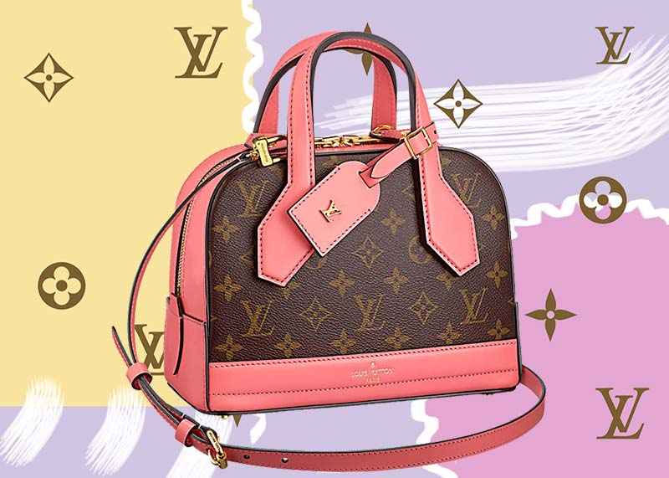](https://www.google.ae/url?sa=i&rct=j&q=&esrc=s&source=images&cd=&cad=rja&uact=8&ved=2ahUKEwjP8uTOzKveAhUi4YUKHXDLD1QQjRx6BAgBEAU&url=https://glowsly.com/best-louis-vuitton-bags/&psig=AOvVaw19KrPKws3-qVi9A4r2wA3M&ust=1540900670178191)

**Practicing the introduction**

**The introduction can have three sentences. Change the yellow, green and blue.**

1. In this essay, I am going to describe my phone.
2. I chose this phone to write about because it is my favorite possession.
3. My parents gave it to me last year.

**Some ways to change the green:**

* …because it is very special to me.
* …because it is my most precious possession.
* …because I love it.

**Some ways to change the blue:**

* **It was a *birthday/graduation* gift from *my brother/my parents.***
* **I bought it *two years ago*/*last week/last year***

1. **Write 3 sentences for an *introduction* for an object that is special for you.**
2. ________________________________________________________________________________________________________________________________
3. ________________________________________________________________________________________________________________________________
4. ________________________________________________________________________________________________________________________________

|  |
| --- |
| **Singular/plural objects**  **Some objects are plural, e.g. *glasses, sunglasses, trousers*, and *shoes.* If the object is plural, change *this* to *these*:**   * ***…this phone to write about…/…these glasses to write about…***   **Change *it is* to *they are + s***   * ***…it is my favorite possession/…they are my favorite possessions*** |

**Practicing paragraph 2**

**Paragraph 2 can have 7 sentences. Change the yellow.**

1. It is a Louis Vuitton bag, and it is very precious.
2. It costs about 50,000 dirhams.
3. It is made of leather and gold, and it is pink and brown.
4. It has three pockets, and it is large.
5. I think it is beautiful.
6. I only use my bag when I go out to a wedding or special occasion.
7. I keep it in my bedroom in my wardrobe.
8. **Write 7 sentences for *paragraph 2* for the object that is special for you.**
9. ________________________________________________________________________________________________________________________________
10. ________________________________________________________________________________________________________________________________
11. ________________________________________________________________________________________________________________________________
12. ________________________________________________________________________________________________________________________________
13. ________________________________________________________________________________________________________________________________
14. ________________________________________________________________________________________________________________________________
15. ________________________________________________________________________________________________________________________________

**Practicing the conclusion**

In conclusion, I love my Louis Vuitton bag. I will keep it all my life, and one day it will belong to my daughter.

1. **Write 2 sentences for *a conclusion* for an object that is special for you.**
2. ________________________________________________________________________________________________________________________________
3. ________________________________________________________________________________________________________________________________

**Plan for describing an object**

1. **Complete the plan with function of each paragraph *P 1 – 3*.**

|  |
| --- |
| **description and use introduction conclusion** |

|  |  |  |
| --- | --- | --- |
| **P** | **function** | **content of paragraph** |
| **1** |  | 1. What it is. |
| 1. Why you chose to ___________ about it. |
| 1. Who bought it/when they bought it. |
| **2** |  | 1. The make/brand, and is it expensive? |
| 1. How much it ____________. |
| 1. What it is made of, and the colors |
| 1. What it has, and the ___________ and weight. |
| 1. What you think of how it looks. |
|  | 1. ___________ you use it. |
|  | 1. Where you ____________ it. |
| **3** |  | 1. What you feel about it. |
| 1. What _____ happen to it in the future, and why. |

1. **Complete the *content of paragraph* section with words from the box below.**

|  |
| --- |
| **will When costs keep size write** |

**Essay organization**

|  |
| --- |
| **Organizing an essay**  **A good essay is organized in a clear way. It has an *introduction*, a *conclusion*, and paragraphs in the middle. Each paragraph has a *main idea*.** |

1. **Put the sentences for each paragraph in order.**

**Introduction** [number sentences **1 – 3**]

I chose this bat to write about because it is amazing.

In this essay, I am going to describe my table-tennis bat.

I bought it last year in a shopping mall in Abu Dhabi.

**Paragraph 2** [number sentences **1 – 7**]

I use my bat every week.

I think it is very stylish.

I keep it at home, because we have a table-tennis table in the garden.

It costs about 300 dirhams.

It is a Stiga, and it is very expensive.

It has two different sides and a handle, and it is very light.

It is made of wood and rubber, and it is red and black.

**Conclusion** [number sentences **1 – 2**]

I will keep it until I am old, and then I will give it to my son.

In conclusion, I love my bat.

**Description essay practice: *a gift***

|  |
| --- |
| *Describe a nice gift someone gave you.* |

**Write here, or type the essay. Write about 100 – 150 words.**

____________________________________________________________________________________________________________________________________________________________________________________________________________________________________________________________________________________________________________________________________________________________________________________________________________________________________________________________________________________________________________________________________________________________________________________________________________________________________________________________________________________________________________________________________________________________________________________________________________________________________________________________________________________________________________________________________________________________________________________________________________________________________________________________________________________________________________________________________________________________________________________________________________________________________________________________________________________________________________________________________________________________________________________________________________________________________________________________________________________________________________________________________________________________________________________________________________________________________________________________________________________________________________________________________________________________________

**[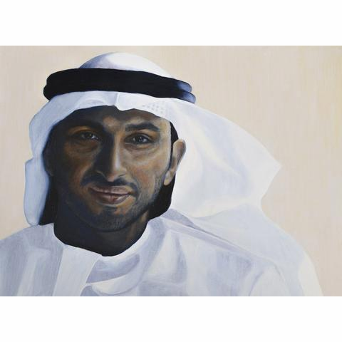](https://www.google.ae/url?sa=i&rct=j&q=&esrc=s&source=images&cd=&cad=rja&uact=8&ved=2ahUKEwijuu_O47neAhVGTBoKHRcHCAcQjRx6BAgBEAU&url=https://www.mondagallery.com/collections/emma-pathare&psig=AOvVaw0SQ7NXi17PiTOc1rqCChxo&ust=1541387874363234)Describing a person**

|  |
| --- |
| 1. In this essay, I am going to describe my best friend. His name is Ahmed, and I met him five years ago. I chose Ahmed to write about because he is important to me. 2. Ahmed is Emirati. He is 28 years old, and he works in a bank in Abu Dhabi. He is single, and he has three brothers and two sisters. He is very kind and generous. His hobbies are watching football and camping in the desert. Ahmed is quite good-looking, and he has short dark hair, a black beard, and brown eyes. He is tall, but he is a little overweight. I see Ahmed every Friday at his house. 3. In conclusion, I am very lucky to have such a good friend. I hope that we will always be friends. (*131 words)* |

1. **Answer questions 1 – 13. Which paragraph (P) *A – C* gives you the answers?**

|  |  |  |  |
| --- | --- | --- | --- |
|  | **question** | **answer** | **P** |
| **1** | Why did the writer choose Ahmed? |  |  |
| **2** | Is Ahmed tall/short/fat/thin? |  |  |
| **3** | What family does Ahmed have? |  |  |
| **4** | What are Ahmed’s hobbies? |  |  |
| **5** | What does Ahmed look like? |  |  |
| **6** | When/where do they see each other? |  |  |
| **7** | How old is Ahmed, and what is his job? |  |  |
| **8** | Are they friends or family? |  |  |
| **9** | What is Ahmed like as a person? |  |  |
| **10** | Does the writer want to stay friends? |  |  |
| **11** | What is his name/when did they meet? |  |  |
| **12** | What does the writer think about Ahmed? |  |  |
| **13** | What nationality is Ahmed? |  |  |

**Vocabulary for describing people**

|  |
| --- |
| **Vocabulary for relationships**  **Nouns: *best friend/a good friend***   * ***Jonathan is my best friend.*** * ***Maria is a good friend.***   **Verbs: to *get on well with* someone/to *spend a lot of time with* someone**   * ***I get on well with my brother Ali.*** * ***I spend a lot of time with my sister Janet.*** |

1. Choose the correct word to complete the sentences.
2. I get on ***well/good*** with Nora.
3. I am going to write about a ***good/best*** friend, John.
4. Who is your ***best/good*** friend?
5. I ***spend/get*** a lot of time with Mary.
6. **Complete the table below with the *description* words from the box.**

|  |
| --- |
| **slim cousin short quiet green father**  **straight generous fair good-looking grandfather** |

|  |  |  |  |  |  |  |  |
| --- | --- | --- | --- | --- | --- | --- | --- |
| **eyes** | **hair** | | **appearance** | | **height/weight** | **relationship** | **personality** |
| blue | brown | |  | | tall | friend | friendly |
| brown | black | | pretty | | medium height | best friend | nice |
| dark |  | | attractive | |  | sister | smart |
|  | grey | | handsome | | overweight | brother |  |
| large | red | | stylish | |  |  | kind |
|  | white | | beautiful | |  | mother | talkative |
|  | long | |  | |  | aunt |  |
|  | short | |  | |  | uncle | shy |
|  |  | |  | |  |  | positive |
|  | curly | |  | |  | grandmother | happy |
|  | wavy | |  | |  |  |  |
|  |  | |  | |  | son |  |
|  | |  | |  | | daughter |  |

**Grammar for describing people**

|  |
| --- |
| **Grammar for descriptions of people**  **Most descriptions are in the *third person singular*: *he/she*.**  **Use *is*:**   * ***He is kind.*** * ***He is Emirati.***   **Use *…s* for present simple:**   * ***She works in an office.***   **For the verb *to have*, use *has*:**   * ***She has long hair.***   **For hobbies, use the *…ing* form:**  ***Her hobbies are shopping and playing basketball.*** |

1. **Read the essay below. Who does it describe?**
2. **Highlight all the examples of the grammar from the box in the essay.**

|  |
| --- |
| In this essay, I am going to describe my cousin. His name is James, and I have known him all my life. I chose James to write about because he is my favorite cousin.  James is English. He is 11 years old, and he goes to school in London. He has three brothers and one sister. He is shy, but he is happy. James is good-looking, and he has short brown hair, big brown eyes and a nice smile. He is short and slim. His hobbies are playing video games and riding a bicycle. I see James every weekend at his home, and we spend a lot of time together.  In conclusion, I am very lucky to have such a nice cousin. I know that we will always be friends. *(130 words)* |

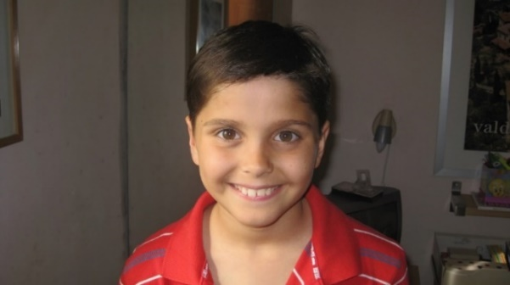

**Practicing the introduction**

**The introduction can have three sentences. Change the yellow, green and blue.**

1. In this essay, I am going to describe my best friend.
2. Her name is Camilla, and I met her ten years ago.
3. I chose Camilla to write about because she is important to me.

**One way to change the green:**

* …have known her all my life.

**Some ways to change the blue:**

* …she is my favorite sister*.*
* …we are very close.
* …she is my best friend.

1. **Write 3 sentences for an *introduction* for a friend who is special for you.**
2. ________________________________________________________________________________________________________________________________
3. ________________________________________________________________________________________________________________________________
4. ________________________________________________________________________________________________________________________________
5. **Write 3 sentences for an *introduction* for someone in your family who is special for you.**
6. ________________________________________________________________________________________________________________________________
7. ________________________________________________________________________________________________________________________________
8. ________________________________________________________________________________________________________________________________

**Practicing paragraph 2**

**Paragraph 2 can have 8 sentences. Change the yellow.**

1. Camilla is American.
2. She is 19 years old, and she is a student in Dubai.
3. She is single, and she has two brothers and a sister.
4. Camilla is friendly and talkative.
5. She is very stylish, and she has long brown hair and dark eyes.
6. She is tall and slim.
7. Her hobbies are making clothes and chatting online.
8. I see Camilla every Friday in Dubai Mall.
9. **Write 8 sentences for *paragraph 2* for a friend or someone in your family.**
10. ________________________________________________________________________________________________________________________________
11. ________________________________________________________________________________________________________________________________
12. ________________________________________________________________________________________________________________________________
13. ________________________________________________________________________________________________________________________________
14. ________________________________________________________________________________________________________________________________
15. ________________________________________________________________________________________________________________________________
16. ________________________________________________________________________________________________________________________________
17. ________________________________________________________________________________________________________________________________

**Practicing the conclusion**

In conclusion, I am very lucky to have Camilla as a friend. I hope that we will always be friends. .

1. **Write 2 sentences for a *conclusion* for a friend or someone in your family.**
2. ________________________________________________________________________________________________________________________________
3. ________________________________________________________________________________________________________________________________

**Plan for describing a *person***

1. **Complete the plan with function of each paragraph *P 1 – 3*.**

|  |
| --- |
| **description and interests introduction conclusion** |

|  |  |  |
| --- | --- | --- |
| **P** | **function** | **content of paragraph** |
| **1** |  | 1. Who + relationship: Friend? _________? Teacher? |
| 1. Name + how __________ you have known them. |
| 1. Why you chose to write about this _________. |
| **2** |  | 1. Nationality. |
| 1. Age + what they do: ________? Student? |
| 1. Family. |
| 1. Personality. |
| 1. Appearance + hair and _________. |
| 1. Height and _________. |
| 1. Hobbies. |
|  | 1. When/where you _________ them. |
| **3** |  | 1. What you feel about them. |
| 1. What you think will happen in the __________. |

1. **Complete the *content of paragraph* section with words from the box below.**

|  |
| --- |
| **person eyes Work future long see Family weight** |

**Essay organization**

1. **Put the sentences for each paragraph in order.**

**Introduction** [number sentences **1 – 3**]

I chose Asia to write about because we are very close.

Her name is Asia, and I have known her all my life.

In this essay, I am going to describe a good friend.

**Paragraph 2** [number sentences **1 – 8**]

She is single, and she does not have any brothers or sisters.

Asia is Italian.

Her hobbies are cooking and playing tennis.

Asia is attractive and stylish, and she has short, wavy hair and brown eyes.

I see Asia when she comes to the UAE.

She is not tall, but she is slim.

She is very smart and positive.

She is 22 years old, and she is a student in Rome.

**Conclusion** [number sentences **1 – 2**]

I know that we will always be friends.

In conclusion, I am very lucky to have such a nice friend.

**Description essay practice 2: *a person***

|  |
| --- |
| *Describe a teacher you remember from school.* |

**Write here, or type the essay. Write about 200 words.**

____________________________________________________________________________________________________________________________________________________________________________________________________________________________________________________________________________________________________________________________________________________________________________________________________________________________________________________________________________________________________________________________________________________________________________________________________________________________________________________________________________________________________________________________________________________________________________________________________________________________________________________________________________________________________________________________________________________________________________________________________________________________________________________________________________________________________________________________________________________________________________________________________________________________________________________________________________________________________________________________________________________________________________________________________________________________________________________________________________________________________________________________________________________________________________________________________________________________________________________________________________________________________________________________________________________________________

**Describing a place**

|  |
| --- |
| **Description questions about places**  **For some EmSAT and Level 1 and 2 writing questions, you have to write an essay describing a *place*.**  **It may be a *building*, *a park,* a *town or city*, or a *country*.** |

1. **What is each question about? Complete the table with words from the box.**

|  |
| --- |
| **a building a country a town or city** |

|  |  |  |
| --- | --- | --- |
| **A** | Write about a town you know very well. |  |
| **B** | Write about a house you love. |  |
| **C** | Write about a country you have visited. |  |

**Vocabulary for places**

1. **What can these words describe? Write the Arabic translation and B *(building)*, T *(town or city)* or C *(country)*. Some can be used for two or three.**

|  |  |  |  |  |  |  |  |
| --- | --- | --- | --- | --- | --- | --- | --- |
|  |  | **Arabic** | **B/C/T** |  |  | **Arabic** | **B/C/T** |
| **A** | living room |  |  | **L** | river |  |  |
| **B** | population |  |  | **M** | bedroom |  |  |
| **C** | neighborhood |  |  | **N** | stylish |  |  |
| **D** | city center |  |  | **O** | modern |  |  |
| **E** | garden |  |  | **P** | traditional |  |  |
| **F** | house |  |  | **Q** | beautiful |  |  |
| **G** | large |  |  | **R** | capital |  |  |
| **H** | detached |  |  | **S** | park |  |  |
| **I** | floors |  |  | **T** | villa |  |  |
| **J** | mountains |  |  | **U** | beaches |  |  |
| **K** | dish |  |  | **V** | food |  |  |

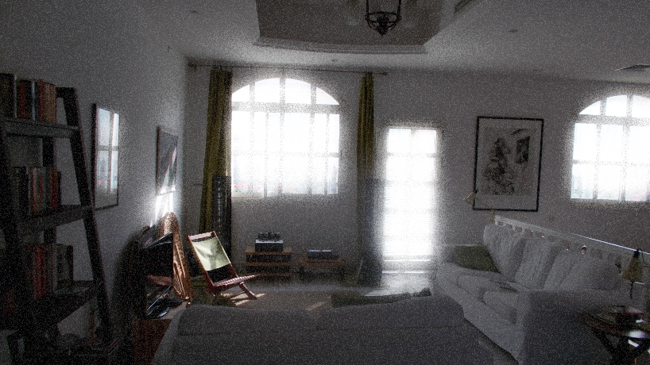**Describing a building**

|  |
| --- |
| **Model essay: a house**  In this essay, I am going *to* describe a house where I am happy. It is my house, and I have lived there for ten years. I chose my house to write about because I love it.  My house is in Mirdiff in Dubai, and it is twelve years old. I live there with my parents and my brother and sister. It is a detached villa, and it is large. It has three floors, two living rooms and four bedrooms. It has a swimming pool, and a small garden. It is modern, and very stylish. I like this house because it is light, with big windows, and the rooms are large. I always feel happy in my house.  In conclusion, I am very lucky to live in such a nice house. I hope that I will live there for ten more years. (*142 words)* |

1. **Read the essay above and answer questions A – L.**
2. How long has the writer lived in the house?
3. Is it small or big?
4. How does the writer feel about the house?
5. How many bedrooms does it have?
6. Does it have a big garden?
7. How old is the house?
8. Is it traditional or modern?
9. When does the writer want to leave the house?
10. Are the rooms small?
11. Where is the house?
12. How many people live in the house?
13. How many paragraphs are there?

[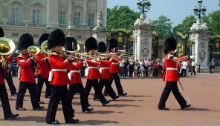](http://www.google.ae/url?sa=i&rct=j&q=&esrc=s&source=images&cd=&cad=rja&uact=8&ved=2ahUKEwi87dLVgN7eAhUBxYUKHcCFA_YQjRx6BAgBEAU&url=http://www.offtolondon.com/june12-free.html&psig=AOvVaw2KvwfIl2M5uStGEdzbCABz&ust=1542632651685195)**Describing a town or city**

1. **Read the model essay below and complete with words from the box.**

|  |  |
| --- | --- |
| **introduction** | city is describe lived |
| **paragraph 2** | are is famous England feel million |
| **conclusion** | am city conclusion live |

|  |
| --- |
| **Model essay: a town or city**  In this essay, I am going to _____________ a _____________ that I love. It is London, and I have ______________ there all my life. I chose London to write about because it _____________ amazing.  London is in ____________, and it is 2000 years old. It is very big, with a population of about 9 million, and it has over 5 ____________ visitors every year. It has many different neighborhoods, such as Knightsbridge, Chelsea and Hampstead. It has beautiful parks and a big river, the River Thames. The most ____________ buildings ____________ Buckingham Palace, the Tower of London and London Bridge. It ____________ a very exciting city. I like London because I __________ happy there.  In _____________, I _____________ very lucky to ____________ in such a great _____________. I hope that I will always live there. (*134 words)* |

[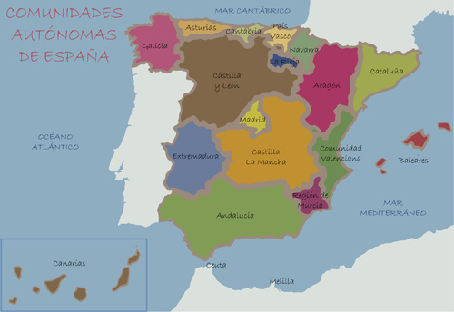](https://www.google.ae/url?sa=i&rct=j&q=&esrc=s&source=images&cd=&cad=rja&uact=8&ved=2ahUKEwiq38zQg97eAhUBxoUKHeLYDRMQjRx6BAgBEAU&url=https://all-free-download.com/free-vector/spain-vector.html&psig=AOvVaw3drgn8IjtI6obKm6HMQPeP&ust=1542633442811053)**Describing a country**

1. **Read the model essay below and complete with words from the box.**

|  |  |
| --- | --- |
| **introduction** | visited Spain about there |
| **paragraph 2** | population friendly Europe fish cities Spanish |
| **conclusion** | great visit will future |

|  |
| --- |
| **Model essay: a country**  In this essay, I am going to describe a country that I ____________. It is Spain, and I went __________ last year. I chose ____________ to write ____________ because it is beautiful.  Spain is in ____________. It is very big, with a ______________ of about 47 million, and it has millions of tourists every year. The capital is Madrid, and it has many other interesting ______________, such as Barcelona and Valencia. Spain has beautiful beaches and mountains. _____________ people love watching football and eating delicious food. A traditional dish is ‘paella’, which is made of rice and _____________. Spain is a very interesting country. I love Spain because I had a great holiday there, and the people were very ____________.  In conclusion, I was very lucky to ________ such a ___________ country. I hope that I _____________return there in the ___________. (*140 words)* |

**Describing *a time in your life***

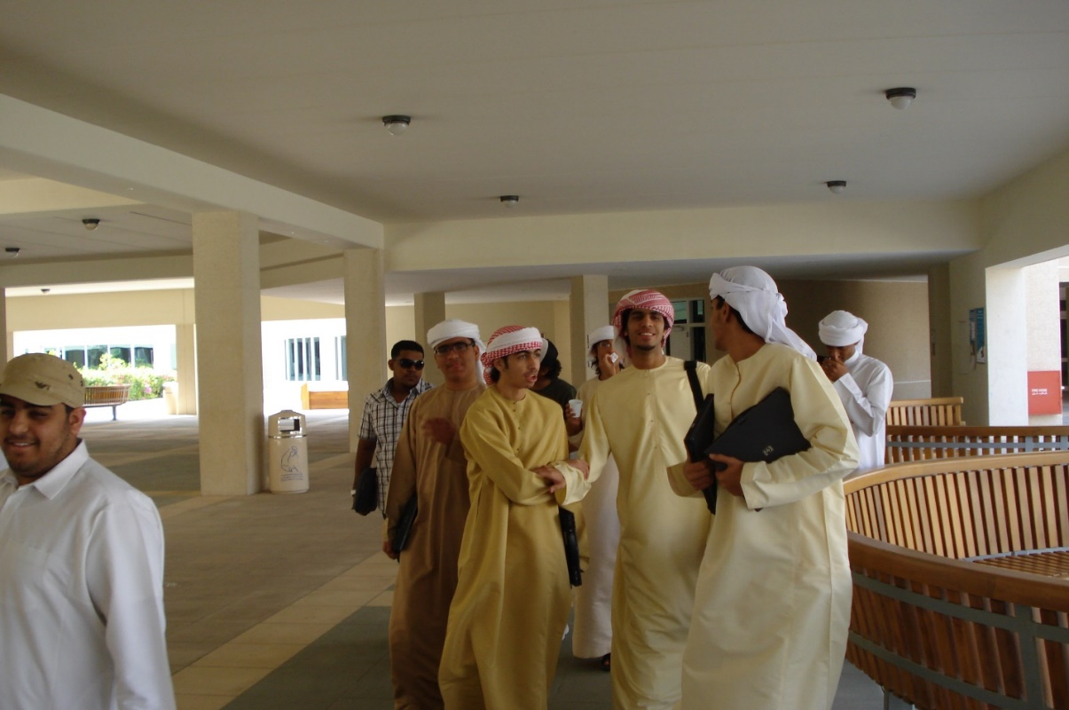

|  |
| --- |
| **Description questions**  **For some description questions, you have to write an essay describing *a time in your life.* It can be a *routine* or a *past time*.**  **Example questions**   * ***Describe your daily routine.*** * ***Describe a great day in your life.*** |

1. **Which questions are *routines,* and which are in the *past*? Write R or P.**

* Describe a day in your life when you were very happy.
* Describe a normal day in your life.
* Describe the best day of your life.
* Describe your first day at college.
* Describe a holiday you remember well.
* Describe what you usually do at the weekend.
* Write a description of a typical day at college.
* What do you usually do at the weekend?

**Describing routines**

1. **Put the sentences about a day at college in order. Write M (morning), A (afternoon) or E (evening) after each one.**

* I go to bed.
* I go home.
* I have lunch.
* I have classes in the afternoon.
* I get up.
* I have coffee with friends.
* I have classes from 8.00 – 9.50.
* I have breakfast.
* I go to college.

1. **Read the essay about *a typical day at college*. Is your order in exercise 2 the same or different?**

|  |
| --- |
| 1. In this essay, I am going to describe a normal day at college. 2. In the morning, I get up early, at about 6 o’clock, and I have breakfast. Then I go to college by car. I am never late for class. Next, I have two English classes. My teachers are Miss Susan and Mr. John, and they are very friendly. After that, I always have coffee with my friends in Starbucks. Then I have two more classes. After that, I have lunch in the cafeteria. In the afternoon, I usually have another two classes. Finally, I go home by car. In the evening, I watch television or do some homework. I go to bed at 11.00. 3. Overall, it is a busy day, and I learn a lot of English. *131 words* |

1. **Read the essay again and answer questions A – F.**
2. Is it a special day or a normal day?
3. What time does he get up?
4. How often does he have coffee with friends?
5. Does he always have two classes in the afternoon?
6. Which word in paragraph C tells you what he feels about the day in general?
7. How does he feel about the day?

**Grammar and vocabulary for describing routines**

|  |
| --- |
| **Verbs**  **Use *verbs* in the *present simple*:**   * ***I get up at 8.00.Then I have breakfast. I am never late.*** |

1. **Choose the correct form of the verb in the *present simple*.**
2. **After that, I *study/studied/am studying*.**
3. **Then I *am going/went/go* to college by bus.**
4. **Finally, I *did/do/am doing* my homework.**

|  |
| --- |
| **Adverbs of frequency**  **Use *adverbs of frequency* before the *verb* or after the *verb to be* to say *how often* you do things:**   * ***I usually have two classes.*** * ***I always go to college by bus.*** * ***I am never late for class.*** |

1. **Write the *adverbs of frequency* in the table, from 100% of the time to 0%.**

|  |
| --- |
| **never always usually sometimes** |

|  |  |  |  |  |  |
| --- | --- | --- | --- | --- | --- |
| **100%** |  |  |  |  | **0%** |

1. **How often do you do these things? Write an *adverb of frequency*. Why is C different?**
2. I _______________ have a big breakfast.
3. I _______________ drive to college.
4. I am ______________ late for class.
5. I _______________ have lunch in the cafeteria.

|  |
| --- |
| **Sequence words**  **Use sequence words to put the events in order. Use a comma, but not after *then*.**   * ***First, I get up.*** * ***Next, I have breakfast.*** * ***Then I do my homework.*** * ***After that, I go to college.*** * ***Finally, I go to bed.*** |

1. **Write the *sequence words* in the table.**

|  |
| --- |
| **next first finally then after that** |

|  |  |
| --- | --- |
| **With a comma** | **No comma** |
|  |  |
|  |  |
|  |  |
|  |  |

1. **Write *sequence words* in the essay about *a normal day at home*.**

|  |
| --- |
| In this essay, I am going to describe a normal day at home.  In the morning, I get up late, at about 9 o’clock, and have breakfast. ______________I do some exercise. ______________, I call my friends and chat. My best friends are Rubi and Sam, and they are very nice. _____________, I usually have lunch with my mother and brother. In the afternoon, I have a short sleep, and _____________ I play computer games. _____________, I always spend time with my little sister. In the evening, I watch television or chat with friends. _____________, I go to bed at 12.00.  Overall, it is a fun day, and I feel happy when I go to sleep. |

1. **Read the essay again and answer questions A – C.**
2. What time does he get up?
3. Does he sleep in the day?
4. Who does he have lunch with?

**Description essay practice: *a typical day***

|  |
| --- |
| *Describe a typical day in your life.* |

**Write here, or type the essay. Write about 100 – 150 words.**

____________________________________________________________________________________________________________________________________________________________________________________________________________________________________________________________________________________________________________________________________________________________________________________________________________________________________________________________________________________________________________________________________________________________________________________________________________________________________________________________________________________________________________________________________________________________________________________________________________________________________________________________________________________________________________________________________________________________________________________________________________________________________________________________________________________________________________________________________________________________________________________________________________________________________________________________________________________________________________________________________________________________________________________________________________________________________________________________________________________________________________________________________________________________________________________________________________________________________________________________________________________________________________________________________________________________________

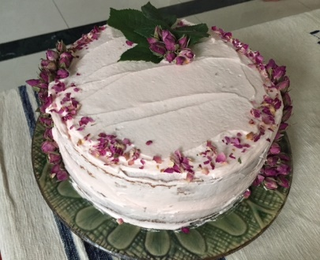**Describing *an event in the past***

1. **Read the essay quickly. What is it about?**

|  |
| --- |
| 1. In this essay, I am going to describe my 17th birthday. I chose this day to write about because it is the best day I can remember. 2. It was on December 15 last year. In the morning, I got up early, at about 8 o’clock. First, I washed and dressed. After that, I went downstairs and had breakfast with my family. Then I opened my gifts. My parents gave me a new iPhone and some clothes. Next, we had a special birthday lunch. In the afternoon, my friends came to my house, and we had a party. They made me a cake. In the evening, I went to the mall with my parents and my sister, and then we had dinner in a restaurant. Finally, I went to bed at midnight. 3. Overall, it was a lovely day, and I will never forget it. |

1. **Read the essay again and answer questions A – F.**
2. Is it a special day or a normal day?
3. What time did she get up?
4. What gifts did her parents give her?
5. What did her friends make her?
6. Where did she have dinner?
7. How does she feel about the day?
8. **Read the essay again and highlight the verbs in paragraph 2. Are they in:**
9. The present simple? *or*
10. The past simple?

**Grammar and vocabulary for describing a day in the past**

|  |
| --- |
| **Grammar and vocabulary for descriptions of days in the past**  **Use *verbs* in the *past simple*:**   * ***I got up at 8.00.Then I had breakfast.***   **Use sequence words to put the events in order. Use a comma, but not after *then*.**   * ***First, I got up very late.*** * ***Next, I had breakfast.*** * ***Then I had a party.*** * ***After that, I went to the mall with my friends.*** * ***Finally, I went to bed.*** |

1. **Write the verbs in the sentences in the past simple, and then number the sentences in order to make a paragraph.**

|  |
| --- |
| **go call be ask decide watch buy** |

* Finally, I ________________ to sleep.
* I __________________ to watch it with my best friend.
* Then we ________________ the football match.
* First, I ________________ my friend and ________________ him to come to my house.
* Next, I ________________ some snacks for us to eat during the match.
* Last week, there _________________ a very good football match between Barcelona and Real Madrid.

[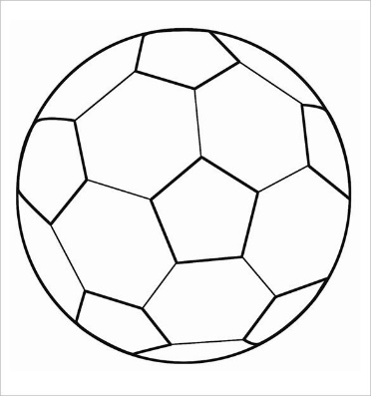](https://www.google.ae/url?sa=i&rct=j&q=&esrc=s&source=images&cd=&cad=rja&uact=8&ved=2ahUKEwjupqnuiYbfAhXqyYUKHV1OD74QjRx6BAgBEAU&url=https://www.template.net/design-templates/print/football-template/&psig=AOvVaw2tkapk3UR6bzBbUeQIYAOI&ust=1544009392743636)

**Description essay practice: *a special day***

|  |
| --- |
| *Describe a special day you remember well.* |

**Write here, or type the essay. Write about 100 – 150 words.**

____________________________________________________________________________________________________________________________________________________________________________________________________________________________________________________________________________________________________________________________________________________________________________________________________________________________________________________________________________________________________________________________________________________________________________________________________________________________________________________________________________________________________________________________________________________________________________________________________________________________________________________________________________________________________________________________________________________________________________________________________________________________________________________________________________________________________________________________________________________________________________________________________________________________________________________________________________________________________________________________________________________________________________________________________________________________________________________________________________________________________________________________________________________________________________________________________________________________________________________________________________________________________________________________________________________________________